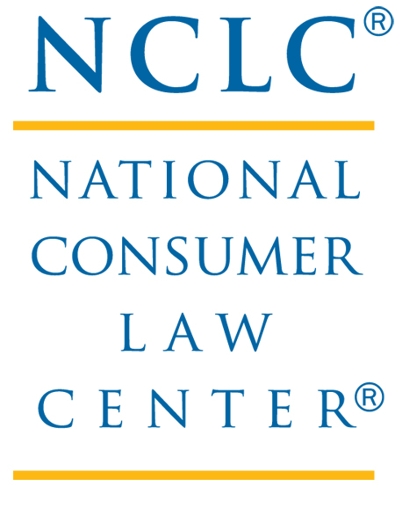
FOR IMMEDIATE RELEASE: APRIL 29, 2011

Contact: Jan Kruse, Director of Communications 617-542-8010
jkruse@nclc.org

NEW RULES KICK IN FOR SOCIAL SECURITY
AND SSI ON MAY 1

BOSTON, MA − Beginning May 1, 2011, elders, veterans, and the disabled can rest a bit easier as a new federal rule kicks in that will limit creditors’ ability to seize funds from Social Security, Social Supplemental Income (SSI), VA, and other federal benefits held in bank accounts in favor of direct deposit or prepaid cards. New rules making the Direct Express® prepaid card the default method of issuing federal payments and limiting the use of other prepaid cards and paper checks will also be in effect May 1.

If a bank receives a garnishment order, the bank will be required to determine whether an account contains electronically deposited federal benefit payments, and if so, the bank will be obligated to protect two months of those payments from seizure to satisfy garnishment orders. To protect funds deposited before the two-month time period, or deposited by check the recipient will have to follow the state procedure for claiming exemptions.

“This regulation will provide a much-needed protection for exempt federal benefits. We are enormously grateful to the U.S. Treasury Department for its leadership in resolving the difficult issue of how to protect federal benefits in bank accounts from illegal seizure,” said Margot Saunders of the National Consumer Law Center. “We also appreciate the Treasury Department’s efforts in the new prepaid card regulation to protect recipients from overdraft and pay-day type loans attached to these new payment devices.”

The U.S. Treasury recently took a hard-line approach regarding elimination of paper checks. Effective May 1 of this year, new applicants filing for all federal payments including Social Security, Supplemental Security Income (SSI), veterans benefits and wages will receive their payments electronically, unless they qualify for one of a very few exemptions. If recipients do not provide information to the federal payment agency regarding a bank account or prepaid card into which they want their payments electronically deposited, they will be provided the federal government-issued Direct Express® card. The Direct Express card is likely to be the best option for recipients who are unbanked, but pursuant to a new rule, they may also choose privately branded prepaid cards to receive their benefits. Additionally, most current recipients will be required to receive their federal benefits electronically as of May 1, 2013.

The Direct Express® prepaid debit card, issued through the U.S. Treasury, is the best prepaid card available. Direct Express® cards have considerable protections for recipients, including limits on fees, legal protection against unauthorized charges, and requirements for free access to funds. They are likely to be substantially less expensive than other prepaid cards.

Nevertheless, if a federal payment recipient wishes to have funds deposited to a prepaid card other than the Direct Express® card, only certain cards are eligible. The most important conditions are that (1) prepaid cards cannot receive federal payments if they are attached to a line of credit or loan agreement that is automatically repaid upon deposit of the federal payment, and (2) the card must comply with consumer protections required through the Electronic Funds Transfer Act (EFTA). Importantly, the EFTA limits overdraft fees for ATM and one-time debit transactions unless the person opts in for such coverage (opting in for overdraft protection may not be beneficial for the recipient). The EFTA protections against unauthorized charges, billing errors, and disclosure of fees will also be in effect for these cards.

Current benefits recipients have until March 1, 2013 to choose an electronic payment option. After that date, no payments will be issued via check, unless the person qualifies and is approved for an exemption.

To continue receiving paper checks, recipients must be approved by the US Treasury for one of the following exemptions:

- Aged 90 years or older, as of May 1, 2011 (no wavier required)
- Mentally impaired
- Live in a remote geographic area lacking the capability to support an electronic financial transaction

Effective March 1, 2013, both new applicants and current recipients who do not choose another option (and have not been granted a wavier) will automatically receive their payments on the federal government’s Direct Express card.

###

National Consumer Law Center® (NCLC®) is a non-profit organization specializing in consumer issues on behalf of low-income and other vulnerable people. Since 1969, NCLC has worked with legal services and nonprofit organizations as well as government and private attorneys across the United States, to create sound public policy for low-income and elderly individuals on consumer issues.

