Building Partnerships
& Community Connections
Approaches to High-Impact Outreach
August 2021

Tenants who face housing insecurity do not always know about free legal aid or where to find it. Many have trouble accessing free legal aid once they know it is available.

This guide offers legal aid organizations ideas they can use to connect with tenants — both directly and through work with established organizations and services — so tenants can more easily find them. Many of the examples come from work already underway at legal aid organizations in Massachusetts.

WHY FOCUS ON CONNECTIONS FOR HIGH-IMPACT OUTREACH?
Building Partnerships & Community Connections aims to help legal aid organizations take new approaches to outreach. Your organization can be more effective with outreach — and have higher-impact — by intentionally building deeper connections in your community. Creating and maintaining these ties is an investment. It requires being a consistent presence so people are familiar with you and your work.

The following pages offer approaches that legal aid organizations can use now and in the future, beyond CELHP, to build these kinds of connections. Specifically, this guide offers ideas for outreach and explains how legal aid organizations can use supporting materials created by MLRI for these efforts. It addresses two elements of outreach:

- Building partnerships to reach tenants through established organizations and services.
- Direct outreach to tenants.

The recommendations are based on focus groups MLRI CELHP conducted with tenants, community partners, and lawyers and paralegals at Massachusetts legal aid organizations. Key findings from these conversations include:

- Tenants connect to legal aid through circuitous paths.
- Many tenants are unaware that free legal aid is available, and/or they had trouble accessing free legal services once they learned about them.
- Tenants have a need to be heard — and to know that the people helping them are listening to their story.
- Making authentic connections is essential.
- This work involves investing time in listening and meeting people where they are, both culturally and in terms of their life circumstances.

DEVELOP YOUR OUTREACH PLAN
Your first step should be creating an outreach plan. Your organization’s plan will depend on factors including your current role in the community, whether community organizations or other potential partners are already working with tenants in the area, how much staff time can be devoted to outreach, and the availability of other resources that can support your efforts.

Whatever you decide to do — and whether it involves a few hours a week or a more concerted effort — make a plan. Think about new approaches; do not just default to past practices. Be intentional about how you spend your outreach time so you can maximize your organization’s impact.

Making an outreach plan involves:

- Setting outreach goals.
- Identifying the strategies you will use. At a minimum, your plan should include:
- Strategies for developing partnerships, including what you will ask each partner to do.
- Strategies for direct outreach.
- Creating a time line for the work.
- Being clear about who is responsible for each step.
- Making sure people have enough time to do the tasks they are undertaking.
- Having regular meetings to assess what is working and then revising your plan as needed.

SUPPORTING MATERIALS
The following materials have been developed to support your outreach efforts, both now and in the future. They are provided as separate documents so you can easily adapt them and/or share them with partner organizations and are available at www.masslegalservices.org/content/building-partnerships.

Suggestions for how to use these materials are made throughout this guide.

- Posters, flyers, ads, and free-standing banners with updated messaging. These materials, designed by a graphic artist and available from MLRI, can be customized for each legal aid organization. They are available in six languages and various sizes. In addition, there is a 211 version available for use statewide and where service areas overlap. Note: The materials have a footer that mentions CELHP, which can be removed. (See page 11 for examples.)
- CELHP laundromat posters and bookmarks. These are available from MLRI and can be customized for each legal aid organizations. (See page 12 for examples.)
- Templates for Direct Tenant Outreach. These template provide sample language for letters, emails, and texts as well as sample scripts for phone calls and voicemails.
- Access to Housing Legal Aid. These are brief talking points that help staff at partner organizations answer tenants’ basic questions about accessing housing legal aid. It can be helpful to provide a laminated copy for the circulation desk at a public library, the front desk at a health clinic, and so on.
- Easy-to-Use Paragraph about Housing Legal Aid. This is concise text about housing legal aid that community partners can use in newsletters, alerts, or other materials.
- Community Organizations & Stakeholder Checklist: Use this checklist to make sure you area considering all possible avenues to develop partnerships.
- Community Legal Education Videos (available soon). These 30- to 60-second videos feature tenants and community advocates providing guidance to tenants. They address a range of housing issues, including unsafe housing conditions, rental assistance, evictions, and how legal help makes a difference.

BUILDING PARTNERSHIPS
Partnerships allow your organization to form new community connections and build on already established ones. When you work with partners, you are able to meet community members through people they already trust and/or in an environment where they regularly spend time.
Identifying Partners
Consider how to expand your existing connections, and think about places where you can build new partnerships. Reassess your community in light of the pandemic. COVID has led to the creation of new organizations, made us more aware of existing organizations, and exposed gaps in services.

Potential partners include the following. Use the Community Organizations & Stakeholder Checklist as you plan for partner outreach.

- Community groups that go door-to-door to give community members information about housing and other assistance.
- Organizations that provide rental assistance and support to apply for rental assistance.
- Organizations that provide community services, including food pantries, food banks, councils on aging, senior centers, and Main Street programs.
- Libraries.
- Places where community members receive health care, including hospitals, health centers, urgent care facilities, and mental health clinics.
- Day care centers, schools, and community colleges.
- Faith-based organizations and houses of worship.
- YMCAs, YWCAs, the United Way, and the Salvation Army.
- Affinity groups, such as Latinos Unidos.
- Labor unions and councils.
- Organizations and individuals that provide support to people facing domestic violence, including social workers, domestic violence advocates, police officers, and district attorney offices.
- Organizations that provide services to individuals and families experiencing homelessness.
- Organizations that provide services to immigrants.
- Grassroots organizations, such as mutual aid organizations, activist coalitions, and tenant associations.
- Places where community members gather and spend time, including barber shops, hair salons, laundromats, buses and bus stops, senior centers, and farmers markets.
- Municipal leaders and elected representatives.

As you identify partners, consider what role they can play in helping to educate tenants about housing rights, available resources, and connecting with your organization. As you think about how partners can fit into your outreach plan, it may be helpful to categorize potential partners into groups, such as:

- Community organizations. These organizations have staff and volunteers whose job is providing services to the community. They are well positioned to identify tenants who might need your support and make referrals. They likely will be your most engaged allies.
- Community colleges, libraries, health centers, houses of worship, and similar groups. These organizations have staff members who provide support to community members. While their day-to-day responsibilities would not typically include making referrals to housing legal aid, they are well positioned to make these referrals.
- Barber shops, hair salons, laundromats, and other places where community members spend time. These locations are least likely to have people who will make referrals, but they are places where community members gather, discuss common issues, and share information about common challenges.

Cultivating Relationships
Building partnerships is an investment that pays off over time. Legal aid staff with existing community relationships can introduce new staff to these partners. New staff also can introduce themselves to potential partners and cultivate new connections. For all staff, outreach offers the opportunity to engage in meaningful community work that goes beyond individual casework.

The types of partnership you cultivate — and what you ask each partner to do — depend on each partner’s capacity and their connections with tenants. The ask should be tailored to the organization. It usually is best to keep your initial asks simple. Then, as you get to know partners, you can work together to identify additional ways to reach out to community members.

Identifying the Ask for each Partner
Tailor your ask for each partner. As you consider what you will ask each organization to do, consider these factors:

- How is the partner viewed in the community? Organizations that already have established trust are in the best position to explain your work and help you deepen your connections with tenants.
- Is the partner already engaged with your organization? If you already have a relationship, you can work to expand your joint efforts.
- Does the partner know how to make referrals to legal aid, or will their staff or volunteers need to learn more about housing legal aid?
- How much time can the partner reasonably commit to your needs? When possible, build on the day-to-day work they already do so they can help you accomplish your goals without adding to their own workload.

Start conversations with potential partners by explaining your work to them. Then explore how best to engage them. Have a few options for joint efforts, and then find the best way to move forward together. Below is a menu of ideas you can discuss with partners.

Partner organizations can:

- Refer clients who need legal aid to your organization. Discuss how their staff and volunteers should make referrals, such as handing tenants contact information for your organization, completing an online form, and so on.
- Provide opportunities for you to share information with their staff. You can talk with staff about housing and evictions in your area, when to make referrals to legal aid, and how to make these referrals. This can happen at in-service trainings or regularly scheduled meetings.
- Distribute information about legal aid. Partners can distribute information, such as a flyer or a bookmark, when they knock on doors, hold community meetings, or conduct other types of outreach in the community.
- Allow your organization to set up an information table. Ask if you can set up a table —staffed by lawyers who can answer questions about housing and legal aid — at one or more of the partner’s events. (For these events, use a banner to call attention to your table and print Know Your Rights flyers in different languages, which you can find at evictionlegalhelp.org.)

- Display a poster about housing legal aid in a high traffic area. This might be near an entrance, near the circulation desk at a library, or in the reception area of a health clinic. Laundromats, barber shops, and hair salons are other places where you might be able to hang a poster or a smaller flyer. For those locations, always check with the owner to make sure you have permission to hang the poster or flyer.
- Have a copy of legal aid talking points available for staff or volunteers who interact with the public. For example, a library might hang a poster near the circulation desk and have the talking points available for anyone who works at that desk. (Use the supporting piece Access to Housing Legal Aid. It can be helpful to laminate these talking points so they are easier to find and last longer.)
- Offer flyers about housing legal aid or bookmarks in visible places. For example, ask libraries and community centers if you can place flyers or bookmarks near the computers they make available for public use.
- Share a short Know Your Rights video on social media, or show it at a meeting. Use the short videos that MLRI will make available.
- Bring the community together for a housing legal aid event. This event might be a housing legal aid clinic or a Know Your Rights session.
- Include information about connecting with housing legal aid when they communicate with their constituents. They can include this information on their website, in newsletters, via social media, or in other outreach. (Use the Easy-to-Use Paragraph about Housing Legal Aid.)

DIRECT OUTREACH
Direct outreach includes all actions that you undertake without a connection to another organization or a specific location. Examples of direct outreach include the following:
Your Current Direct Outreach Activities
Many legal aid organizations send letters, send emails, and make phone calls to people who have had eviction actions filed against them in court. Building on the work of legal aid organizations, CELHP developed templates for this outreach with language that is simple, aims to connect with tenants, and encourages tenants to reach out to legal aid. If you are mailing letters, you also may consider adding the color flyer (shown on page 11) to the envelope. It may catch the eye of some of the tenants and make it more likely that they will read your letter.

Activities from Partners List
In areas where there are few or no established community organizations, you might consider piggybacking on events, such as farmers markets, block parties, or Main Street events. You also can host your own activities or events. Be aware that without a community organization as a partner, you will have to publicize the event, host the event, and help set people at ease when they arrive.

Activities That Make You Visible in the Community
There is value in being visible in the community, and if you have a staff member or volunteer who can spend time in the community, they will become known. You can, for example:

- Set up a table with a housing legal aid banner in a prominent location, and talk with people who walk by. Offer an incentive — e.g., lemonade and cookies — for people to stop. (If you offer food or drink, avoid common allergens and know the ingredients in what you are offering.)
- Hang flyers and posters in areas where people typically congregate.
- Ask a library if you can set up a table once a month in a prominent location.
- Spend time in locations where people typically congregate.
- Hire an ice cream truck for two hours, set up your housing legal aid banner, and pick up the tab for kids’ ice creams. Talk with their families about free legal aid.

Social Media
Many legal aid organizations already are active on social media. Following are tips for using social media to your advantage.

- Have a clear voice (point of view and tone), and post regularly.
- Build a following by following and commenting on the posts of others who are prominent in your community.
- Repost housing-related news and information from your community.
- Post quotes from tenants about working with you, with their permission.
- Share tenants’ stories, with their permission.
- Share information that will be novel or unusual. Something that is outside of people’s normal routine will attract attention and get reposted.
- Post about your accomplishments. Saying “X families stayed in their home this week because of [organization]” will get attention and inspire people who need help to call.
- Place ads on social media. Note that Facebook ads can run in multiple places, including in the Facebook News Feed, Instagram feed, and even in Messenger. Check your settings, and make sure you are using every platform that is a good fit for your organization.
- Share the CELHP videos and graphics so your posts attract attention when followers are scrolling through their feeds; videos and graphics also improve the odds of your posts appearing in followers’ feeds.
- Include hashtags, particularly if the topic is trending. Be sure to check the hashtag before you use it to make sure it is not being used by someone or for some purpose you do not want to be associated with.
- Establish a regular posting schedule and check the analytics to see which types of posts, on which platforms, and at which times are generating the most activity (likes, retweets, clickthroughs to a URL, etc.). Then finetune your strategy.

Social Media Musts
No matter what you post, always follow these rules:
- Be respectful of everyone you interact with, even when people are not being respectful toward you.
- Be honest, professional, and polite.
- Be sure that any images you use are owned by you, in the public domain, or used with the permission of the owner.
- Correct your mistakes. Acknowledge mistakes and correct them as quickly as possible.
POSTERS, FLYERS, ADS, AND BANNERS
These are examples of materials that CELHP offers in various sizes and languages, customized for each legal aid organization. In addition to English, the materials are available in Chinese, Haitian Creole, Portuguese, Spanish, and Vietnamese.

Poster (11" x 17" and 24" x 36")
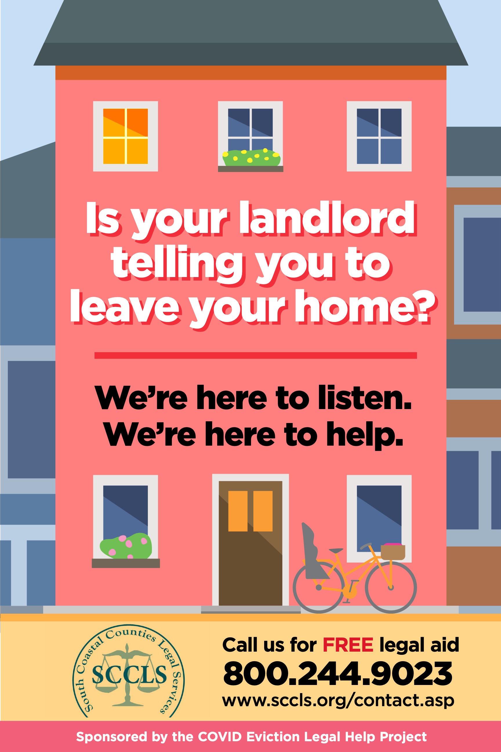

Flyer (8.5" x 11")

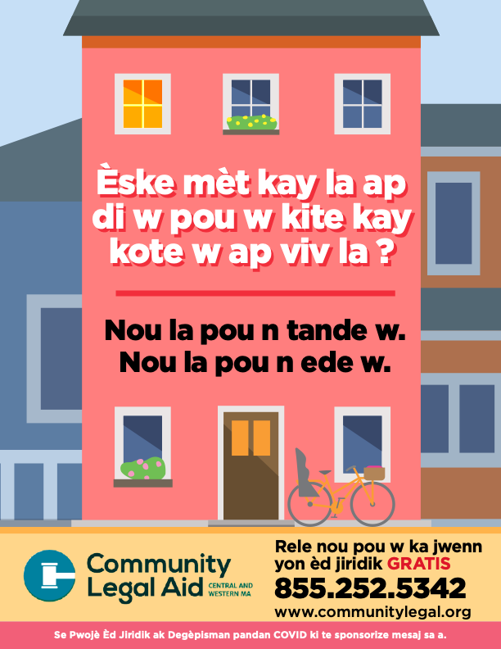

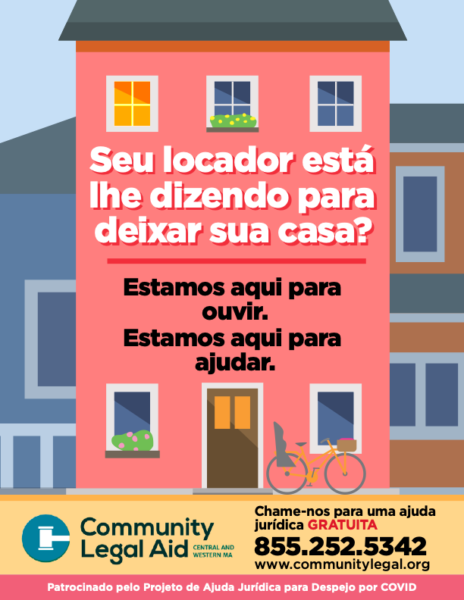

Advertisement (sized for social media, print ads, etc.)

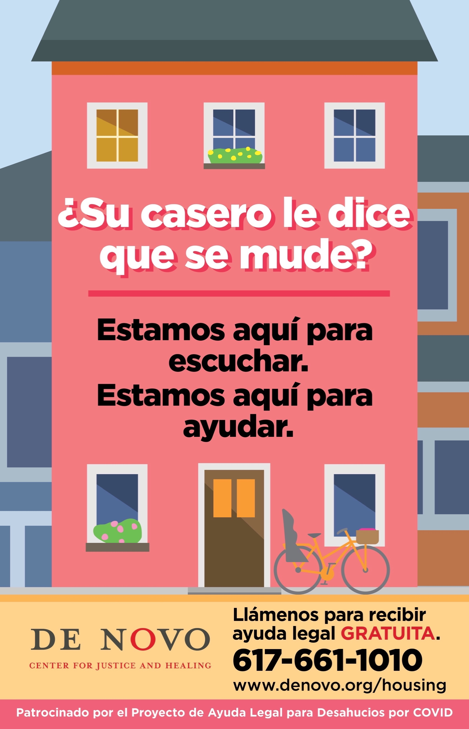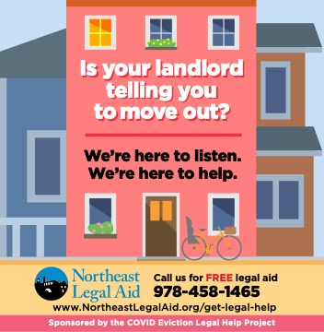

Free-standing vertical banner (33" x 78")

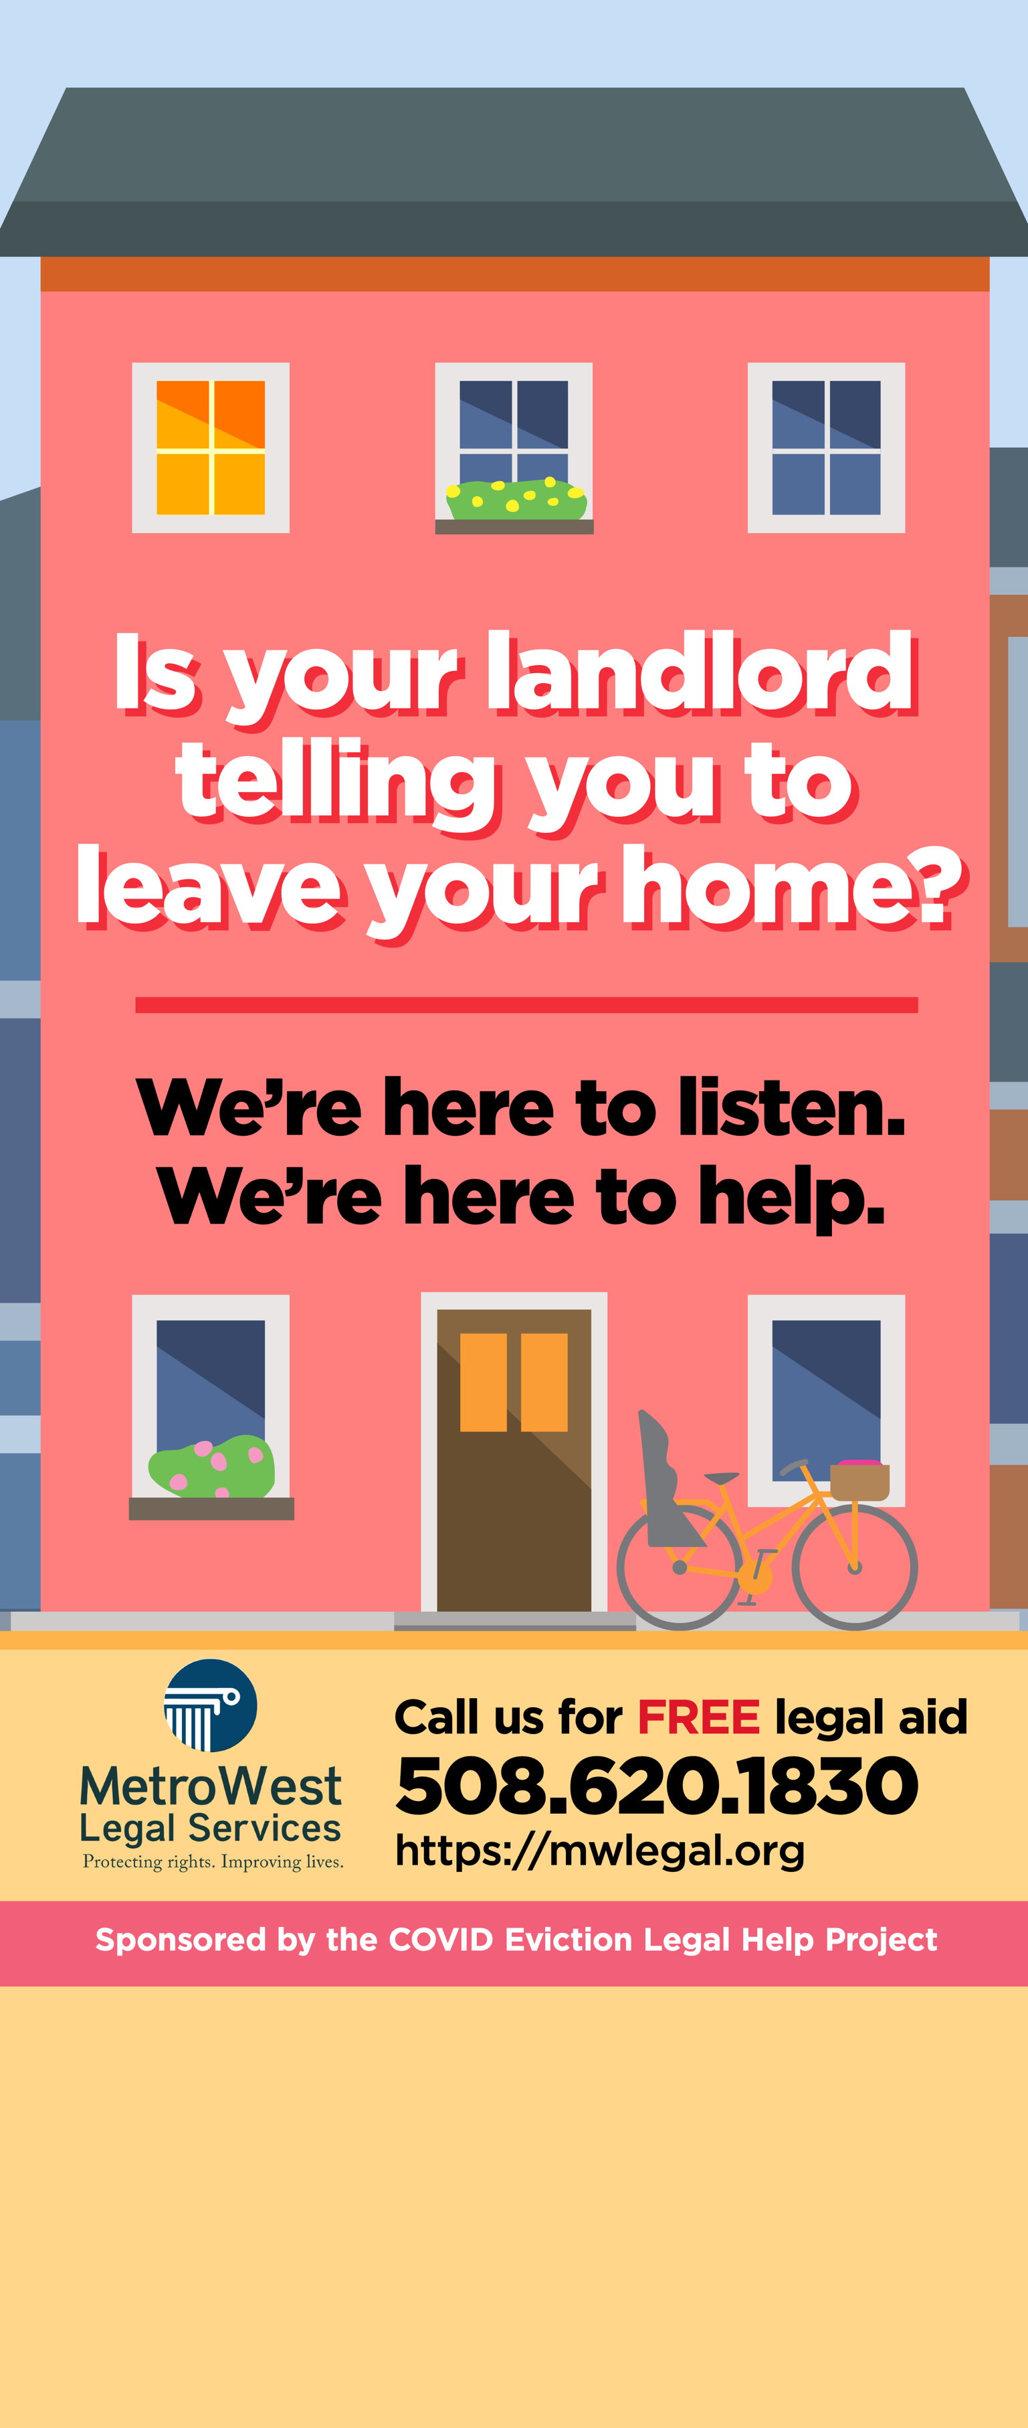

LAUNDROMAT POSTERS AND BOOKMARKS

Poster (8.5" x 14")

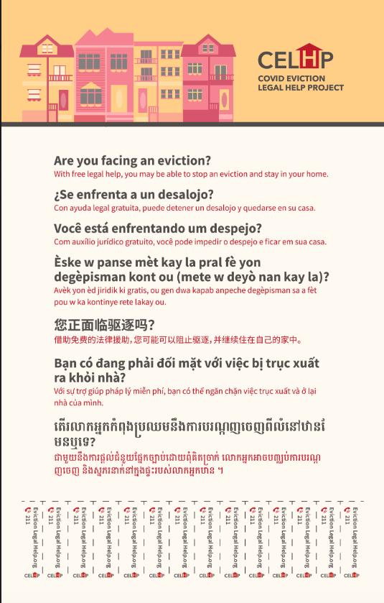

Bookmark (2" x 6")

