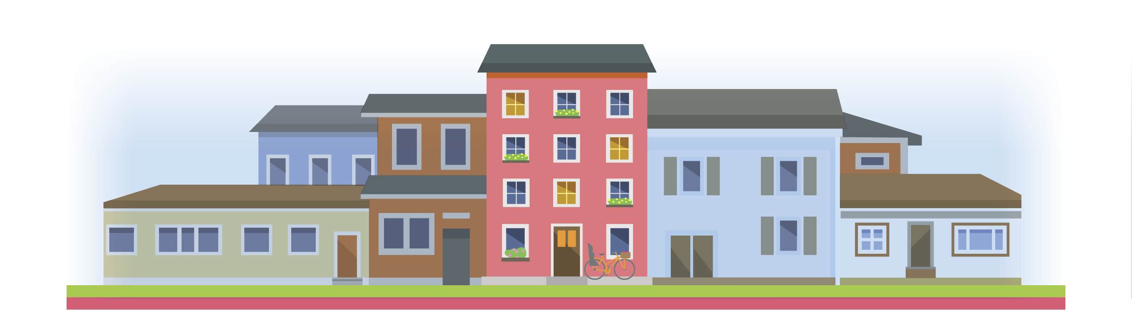
Community Organizations & Stakeholder Checklist
Identifying Partners & Places Where People Gather

- Homelessness service providers
- Immigrant service providers
- Domestic violence service providers
- Other service providers
- Food pantries and food banks
- United Way
- Salvation Army
- YMCAs and YWCAs
- Community health centers
- Urgent care facilities
- Hospitals
- Mental health service providers
- Day care centers
- Community organizations
- Community action agencies
- Organizations that provide rental assistance
- Main Street programs
- Activist coalitions
- Mutual aid organizations

- Affinity groups
(ex. Latinos Unidos Faith-based organizations)
- Labor unions and councils
- Tenant associations
- Senior centers
- Councils on aging
- Elder services
- Municipal leaders
- Local and State elected officials
- District attorney offices
- Police departments
- Elementary Schools
- Junior High and High School
- Community colleges
- Teachers associations
- Public libraries
- Barber shops & hair salons
- Laundromats
- Buses and bus stops
- Farmers markets

