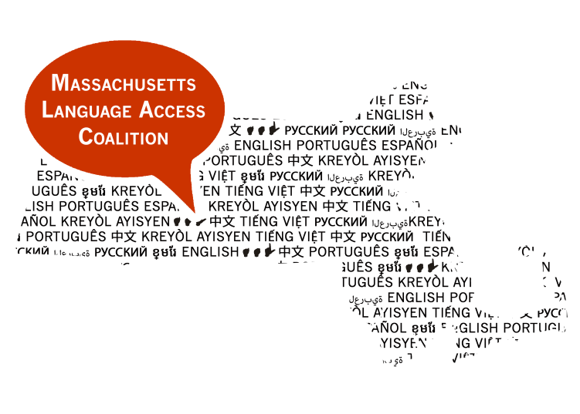
The Massachusetts Language Access Coalition
Presents the Second Annual
Language Access Conference
Beyond Service, Toward Empowerment
Friday, June 26, 2015 – 9:30am-4pm
UMASS Medical School, 55 North Lake Avenue, Worcester, MA 01655

For more information and to register online, visit
www.universe.com/MALanguageAccess2015

To register by mail, please send completed Registration Form and $25 check payable to:
Massachusetts Law Reform Institute
Attn: Kendra Sena
99 Chauncy Street, Suite 500
Boston, MA 02111
Memo line: LAC Conference
Limited scholarships available, please contact: ksena@mlri.org or 617-357-0700, ext. 350
Registration Form

Name:

Title:

Organization Name:

Address:

E-mail:

Phone Number:

Dietary restrictions:

Accommodations:

