
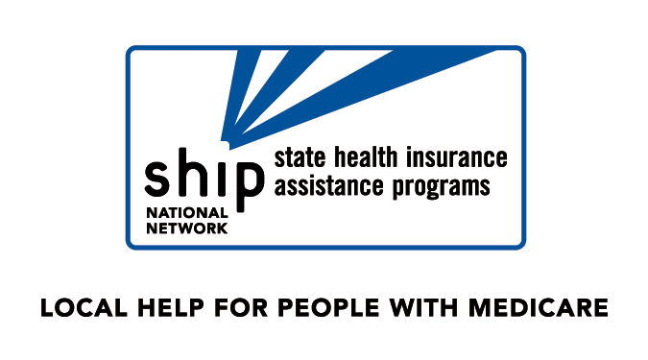
2011 Medicare Part A Benefits and Gaps
(Chart outlines gaps in Medicare coverage. Refer to Medicare & You Handbook for more
Information about Medicare benefits.)
Coverage | Beneficiary Pays | Medicare Pays
Medicare Part A
Inpatient Hospital Care*  Days 1-60  Days 61-90  Days 91-150 (lifetime reserve days)  All additional days  Semiprivate room and board, general nursing, and other hospital services and supplies. | $1132 deductible  $283 per day  $566 per day  All costs | Balance  Balance  Balance  Nothing
Skilled Nursing Facility Care*  Days 1-20  Days 21-100  All additional days  After three-day hospitalization and admitted to a skilled nursing facility approved by Medicare within 30 days of discharge. | Nothing  $141.50 per day  All costs | All costs  Balance  Nothing
Home Health Care  Part-time or intermittent skilled care, home health aide services | Nothing | Up to 35 hours per week
Durable Medical Equipment and Supplies | 20% of approved amount | 80% of approved amount
Hospice Care  Pain relief, symptom management and support services for the terminally ill. | Small co-payments for inpatient respite and drugs | Balance
Blood | For first 3 pints | All but first 3 pints per calendar year

*A benefit period provides 90 days of hospital care, if needed. A new benefit period begins each time the beneficiary is out of the hospital or has not received skilled nursing care from any other facility for 60 consecutive days.

Part A Premiums for Voluntary Enrollee (individuals who must purchase Part A):
30-39 work quarters $248/month in 2011
0-29 work quarters $450/month in 2011

Refer to Medicare & You Handbook for more information about Medicare benefits. Or call Medicare at 1-800-633-4227 TTY: 1-877-486-2048
2011 Medicare Part B Benefits and Gaps
(Chart outlines gaps in Medicare coverage. Refer to Medicare & You Handbook for more information about Medicare benefits.)
Coverage | Beneficiary Pays | Medicare Pays

Medicare Part B
Medical Expenses  - Doctors’ services  - Inpatient and outpatient medical services and supplies  - Physical and speech therapy  - Diagnostic tests  - Ambulance services  Medicare also pays for other medically necessary services, see Medicare Handbook. | $162 deductible* plus  20% **of Medicare's approved amount.  Limited charges above the approved amount may apply for some Part B providers. | 80% of Medicare’s approved amount after $162 deductible has been met.  55% for most outpatient mental health services -will increase each year -80% by 2014
Clinical Lab Tests  Blood tests, urinalysis, and more. | Nothing for tests if medically necessary. | Generally 100% of approved amount.
Home Health Care  Part-time or intermittent skilled care, home health aide services | Nothing | Up to 35 hours per week
Durable Medical Equipment and Supplies | After $162 deductible, you pay 20% of approved amount | 80% of approved amount after $162 deductible
Outpatient Hospital Treatment | After $162 deductible, you pay a co-payment according to the service. | Medicare payment to hospital based fee schedule.
Blood | For first 3 pints, plus 20% of approved amount (after $162 deductible). | 80% of approved amount (after $162 deductible and starting with the 4th pint).
* Once you have incurred $162 of expenses for Medicare-covered services in any year, the Part B deductible does not apply to any further covered services you receive for the rest of the year.
** Part B Coinsurance is paid after you have met the annual Part B deductible of $162 for covered services in 2011. Most beneficiaries will continue to pay $96.40 or $110.50 for the 2011 Part B premium. Some beneficiaries including those new to Medicare, beneficiaries who don’t collect a Social Security check and beneficiaries with higher incomes will pay higher Part B premiums. The premium for the above members will range from $115.40- $369.10.

Services Not Covered by Medicare (partial list only): Private Duty Nursing, Experimental Procedures, Care Outside of the U.S., Custodial Care at Home, Custodial Care in Nursing Home, Outpatient Prescription Drugs, Hearing Aids, Eyeglasses ( generally), Most Chiropractic Services, Dental Care, Acupuncture, or Private Hospital Room.

