Where the claimant relied upon the school’s representation that it was Section 30 approved, but, in fact, its approval had lapsed, then reinstated a few weeks after she enrolled, the Board refused to penalize the claimant for the school’s error. Held the claimant was entitled to Section 30 benefits even though the program was not approved at the time of the claimant’s application.

Board of Review Paul T. Fitzgerald, Esq.
19 Staniford St., 4th Floor Chairman
Boston, MA 02114 Stephen M. Linsky, Esq.
Phone: 617-626-6400 Member
Fax: 617-727-5874 Judith M. Neumann, Esq.
Member
Issue ID: 0015 7145 16
BOARD OF REVIEW DECISION

Introduction and Procedural History of this Appeal

The claimant appeals a decision by Jodi Ferullo, a review examiner of the Department of Unemployment Assistance (DUA), to deny unemployment training benefits. We review, pursuant to our authority under G.L. c. 151A, § 41, and reverse.

The claimant separated from employment and filed a claim for unemployment benefits, which was approved, effective December 7, 2014. On March 5, 2015, the claimant filed an application with DUA for an extension of benefits to attend a training program, which was denied in a determination issued on April 9, 2015. The claimant appealed the determination to the DUA hearings department. Following a hearing on the merits, attended by the claimant, the review examiner affirmed the agency’s initial determination and denied training benefits in a decision rendered on June 23, 2015. We accepted the claimant’s application for review.

Training benefits were denied after the review examiner determined that the claimant’s training program had not been approved by the DUA Training Opportunities Program at the time she submitted her application and, thus, she did not meet the requirements for training benefits, pursuant to G.L. c. 151A, § 30(c). After considering the recorded testimony and evidence from the hearing, the review examiner’s decision, and the claimant’s appeal, we afforded the claimant and the DUA an opportunity to submit written reasons for agreeing or disagreeing with the decision. Neither responded. Our decision is based upon our review of the entire record.

The issue before the Board is whether the review examiner’s conclusion that the claimant is not entitled to G.L. c. 151A, § 30, benefits because, at the time she submitted her application, the school’s approval had lapsed is supported by substantial and credible evidence and is free from error of law.

Findings of Fact

The review examiner’s findings of fact and credibility assessments are set forth below in their entirety:

- The claimant filed her clam for unemployment benefits on December 12, 2014. The effective date of the claim is December 7, 2014.

- Prior to filing her claim for unemployment benefits, the claimant had worked as a server in a restaurant for a two-year period. The claimant became separated from employment when the restaurant closed.

- The claimant filed her claim for unemployment benefits in person. The claimant requested to receive her correspondence from the Department electronically.

- On March 5, 2015 the claimant submitted a Section 30 Training Opportunities Program Application. The training program indicated was Aliano School of Cosmetology, Inc. The name of the program was Cosmetology with a start date of March 9, 2015 and a completion date of December 7, 2015. The program was five days per week for a total of 25 hours per week. The duration of the training program was 40 weeks, with an 80% placement rate in training related jobs.

- Upon completion of the program, the claimant will have a certificate in Cosmetology, which will allow her to take the examination to obtain a license and work in Cosmetology.

- The Aliano School of Cosmetology, Inc., Cosmetology program, was approved with the DUA TOPS unit with an expiration date of June 11, 2014. For unknown reason after June 11, 2014, the school did not renew their program with the TOPS unit until April 3, 2015.

- On April 9, 2015 a Redetermination Notice of Disqualification was issued in accordance with Section 30 of the Law, indicating that “you are not approved for Training Opportunities Program benefits while attending the Cosmetology program at Ailano School of Cosmetology from 3/9/2015 – 12/07/2015. The school or training program has not applied for approval since its expiration on 6/11/2014 on TrainingPro/MOSES. The program was not renewed and approved again until 4/3/2015. You may apply with an approvable program. To be considered for the TOP extension you must submit your application before 4/18/2015.” The claimant filed an appeal to that determination.

Ruling of the Board

In accordance with our statutory obligation, we review the decision made by the review examiner to determine: (1) whether the findings are supported by substantial and credible evidence; and (2) whether the review examiner’s ultimate conclusion is free from error of law. Upon such review, the Board adopts the review examiner’s consolidated findings of fact and deems them to be supported by substantial and credible evidence. However, as discussed more fully below, we reject the review examiner’s legal conclusion that the claimant is not eligible for G.L. c. 151A, § 30 benefits.

This case involves the application of G.L. c. 151A, § 30(c), which relieves claimants who are enrolled in approved training programs of the obligation to search for work and permits extensions of up to 26 weeks of additional benefits. The procedures and guidelines for implementation of training benefits are set forth in 430 CMR 9.00–9.09. Training programs must be approved by DUA in order for the enrolled claimant to be eligible for the extended benefits. 430 CMR 9.04(2).

The review examiner disqualified the claimant because, at the time she submitted her G.L. c. 151A, § 30, application, her cosmetology program’s approval to participate in the DUA Section 30 program had lapsed. The examiner failed to acknowledge evidence that the school had led the claimant to believe that its program was approved. In a recent decision involving another student enrolled in the same training program who was disqualified for the same reason, the Board stated, “We are mindful of the plight of claimants, like this one, who rely upon the representations of school officials that their school’s program has been approved for training benefits. We also recognize that schools may not always realize that a program’s eligibility has expired.” Board of Review Decision 0014 7320 67 (August 19, 2015) (held claimant was eligible for G.L. c. 151A, § 30, benefits while attending her cosmetology training program). Although it is not clear why the school’s approval had lapsed, Finding of Fact # 7 shows that the program reobtained its approval status effective April 3, 2015, four weeks after the claimant filed her G.L. c. 151A, § 30, application.

Here, as in Board of Review Decision 0014 7320 67, we decline to penalize her for the program’s lapse in approval.

We, therefore, conclude as a matter of law that the claimant’s program satisfies the requirements of G.L. c. 151A, § 30(c), and 430 CMR 9.00 et seq.

The review examiner’s decision is reversed. The claimant is entitled to receive training benefits for the period March 9, 2015, through December 7, 2015, if otherwise eligible.

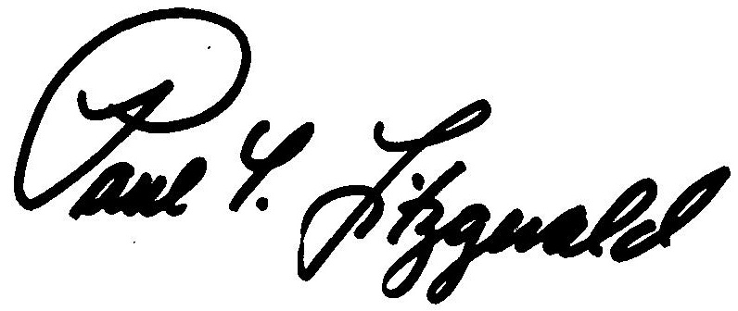
BOSTON, MASSACHUSETTS Paul T. Fitzgerald, Esq.
DATE OF DECISION - September 24, 2015 Chairman

Judith M. Neumann, Esq.
Member

Member Stephen M. Linsky, Esq. did not participate in this decision.

ANY FURTHER APPEAL WOULD BE TO A MASSACHUSETTS STATE DISTRICT COURT OR TO THE BOSTON MUNICIPAL COURT
(See Section 42, Chapter 151A, General Laws Enclosed)

The last day to appeal this decision to a Massachusetts District Court is thirty days from the mail date on the first page of this decision. If that thirtieth day falls on a Saturday, Sunday, or legal holiday, the last day to appeal this decision is the business day next following the thirtieth day.

To locate the nearest Massachusetts District Court, see:
www.mass.gov/courts/court-info/courthouses

Please be advised that fees for services rendered by an attorney or agent to a claimant in connection with an appeal to the Board of Review are not payable unless submitted to the Board of Review for approval, under G.L. c. 151A, § 37.

AB/rh

While not explicitly incorporated into the review examiner’s findings, the claimant’s testimony that she asked the school before applying whether it was approved under G.L. c. 151A, § 30, and they said, “Yes,” is part of the unchallenged evidence introduced at the hearing and placed in the record, and it is thus properly referred to in our decision today. See Bleich v. Maimonides School, 447 Mass. 38, 40 (2006); Allen of Michigan, Inc. v. Deputy Dir. of Department of Employment and Training, 64 Mass. App. Ct. 370, 371 (2005).
Board of Review Decision 0014 7320 67 is an unpublished decision, available upon request. For privacy reasons, identifying information is redacted.

