Claimant’s subsequent approval for training benefits under § 30 after a DUA hearing, applied retroactively to when she actually began training, also permits retroactive waiver of the availability and work search requirements under § 24(b), for the same period.

Board of Review Paul T. Fitzgerald, Esq.
19 Staniford St., 4th Floor Chairman
Boston, MA 02114 Judith M. Neumann, Esq.
Phone: 617-626-6400 Member
Fax: 617-727-5874 Charlene A. Stawicki, Esq.
Member
Issue ID: 0016 1171 46
BOARD OF REVIEW DECISION

Introduction and Procedural History of this Appeal

The claimant appeals a decision by Eric M. P. Walsh, a review examiner of the Department of Unemployment Assistance (DUA), to deny unemployment benefits. We review, pursuant to our authority under G.L. c. 151A, § 41, and reverse.

The claimant was separated from full-time employment on January 29, 2015. She filed an initial claim for unemployment benefits with the DUA, which was subsequently approved. On March 26, 2015, the claimant submitted an application for training benefits, and began a full-time course of study on April 20, 2015. On April 25, 2015, the DUA denied the claimant’s application for training benefits. The claimant appealed that disqualification to the DUA hearings department. Following a hearing on the merits, another DUA review examiner overturned the agency’s disqualification and awarded the claimant training benefits in a decision rendered on June 5, 2015.

On May 23, 2015, the DUA issued a determination disqualifying the claimant from unemployment benefits beginning on April 19, 2015, the week the claimant began her training program. The claimant appealed the determination to the DUA hearings department. Following a hearing on the merits, attended by the claimant, the review examiner affirmed the agency’s disqualification. We accepted the claimant’s application for review.

Benefits were denied after the review examiner determined that the claimant was not available for full-time work in an occupation for which she is reasonably fitted during the period between when she began training (April 20, 2015) and when her application for training benefits was ultimately approved (June 4, 2015) and, thus, was disqualified, pursuant to G.L. c. 151A,
§ 24(b). Our decision is based upon our review of the entire record, including the recorded testimony and evidence from the hearing, the review examiner’s decision, the claimant’s appeal, and information from the claimant’s UI Online account with the DUA.

The issue before the Board is whether the claimant, who was retroactively awarded training benefits after appeal, is eligible for a corresponding retroactive waiver of work search requirements while participating in her full-time, DUA-approved training program.

Findings of Fact

The review examiner’s findings of fact are set forth below in their entirety:

- On January 29, 2015, the claimant was laid off from her full-time employment, at which time she continued a claim, initially filed for partial benefits with an effective date of with an effective date January 4, 2015.

- On March 26, 2015, the claimant applied for Section 30 benefits.

- On April 20, 2015, the claimant began a full-time course of study in a certificate program.

- The DUA denied the claimant’s Section [30] application and she appealed.

- On June 5, 2015, the claimant received a favorable decision on [her Section 30] appeal.

Ruling of the Board

In accordance with our statutory obligation, we review the decision made by the review examiner to determine: (1) whether the findings of fact are supported by substantial and credible evidence; and (2) whether the review examiner’s ultimate conclusion is free from error of law. Upon such review, the Board adopts the review examiner’s findings of fact and deems them to be supported by substantial and credible evidence. However, as discussed more fully below, we reject the review examiner’s legal conclusion that although the claimant’s application for training benefits was retroactively approved after a DUA hearing, her availability and work search waivers should not also be retroactively applied for the same period.

The review examiner disqualified the claimant from benefits during the period between when she began a training program and when her participation in the training program was approved by the DUA, pursuant to G.L. c. 151A, § 30(c), which relieves claimants who are enrolled in approved training programs of the obligation to search for work, and permits extensions of up to 26 weeks of additional benefits. The statutory foundation for relief of the requirement to apply for or accept suitable work is found in G.L. c. 151A, § 25(c), which states, in pertinent part:

An individual who is certified as attending an industrial retraining course or other vocational training course as provided under section thirty shall not be denied benefits … relating to failure to apply for, or refusal to accept, suitable work.

The procedures and guidelines for implementation of training benefits are set forth in 430 CMR 9.00–9.09. Under G.L. c. 151A, § 30(c), it is the claimant’s burden to prove that she fulfills all of the requirements to receive a training extension.

The regulations that govern training benefits establish both procedures and standards for approving training programs themselves, as well as the eligibility criteria for claimants seeking to participate in such programs. See 430 CMR 9.01.

430 CMR 9.04(1)(c) states:

A claimant shall be eligible … during the pendency of any dispute regarding eligibility for leaving work under M.G.L. c. 151A, § 25(e), provided the claimant is receiving benefits ….

430 CMR 9.07(2) states:

Participants approved under M.G.L. c. 151A, § 30(c) shall not be required to engage in work search activities, and shall be deemed available for suitable work during any week in which the participant is in attendance at the approved training program, or during an approved break in training ….

However, 430 CMR 9.06(2)(b) states:

A claimant who begins a training program prior to final approval of an application shall not be eligible for waiver under 430 CMR 9.07(2) of the requirements for work search or availability for suitable work from the first date of such attendance until the date claimant’s application is approved.

We believe it to be inherent within 430 CMR 9.07(2) that the availability and work search requirements are deemed fulfilled retroactively for the period of time that a claimant is participating in an approved training program, even if the approval occurs as the result of an appeal of an initial disqualification. As we have previously held, while the purpose of 430 CMR 9.06(2)(b) encourages applicants to begin training programs only after the DUA has approved their training, we do not believe it should not bar participants from training or training benefits where the DUA eventually decides that their application should have been approved to begin with. See Board of Review Decision 0014 3796 00 (March 5, 2015) and Board of Review Decision 0014 6370 92 (June 29, 2015).

We, therefore, conclude as a matter of law that the claimant’s approval for training benefits, applied retroactively to the date she actually began training, permits retroactive waiver of the availability and work search requirements, under G.L. c. 151A, § 24(b), for the same period.

The review examiner’s decision is reversed. The claimant is entitled to receive benefits, without the imposition of a constructive deduction, for the week ending March 7, 2015, and for subsequent weeks, if otherwise eligible.
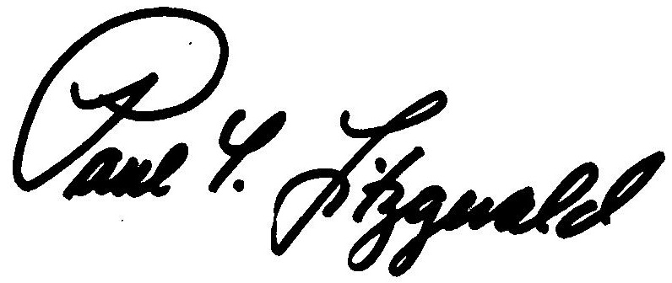
BOSTON, MASSACHUSETTS Paul T. Fitzgerald, Esq.
DATE OF DECISION - December 18, 2015 Chairman

Judith M. Neumann, Esq.
Member

Member Charlene A. Stawicki, Esq. did not participate in this decision.

ANY FURTHER APPEAL WOULD BE TO A MASSACHUSETTS STATE DISTRICT COURT OR TO THE BOSTON MUNICIPAL COURT
(See Section 42, Chapter 151A, General Laws Enclosed)

The last day to appeal this decision to a Massachusetts District Court is thirty days from the mail date on the first page of this decision. If that thirtieth day falls on a Saturday, Sunday, or legal holiday, the last day to appeal this decision is the business day next following the thirtieth day.

To locate the nearest Massachusetts District Court, see:
www.mass.gov/courts/court-info/courthouses

Please be advised that fees for services rendered by an attorney or agent to a claimant in connection with an appeal to the Board of Review are not payable unless submitted to the Board of Review for approval, under G.L. c. 151A, § 37.

JPC/rh

These Board of Review Decisions are unpublished decisions, available upon request. For privacy reasons, identifying information is redacted.

