A temporary employee who, prior to filing for benefits, communicates with the employer at the completion of his current assignment without specifically requesting reassignment, and who does not assert that he is unavailable for work, has met the requirements of G.L. c. 151A, § 25(e).

Board of Review Paul T. Fitzgerald, Esq.
19 Staniford St., 4th Floor Chairman
Boston, MA 02114 Stephen M. Linsky, Esq.
Phone: 617-626-6400 Member
Fax: 617-727-5874 Judith M. Neumann, Esq.
Member
Issue ID: 0014 4820 58
BOARD OF REVIEW DECISION

Introduction and Procedural History of this Appeal

The claimant appeals a decision by Sandor Zapolin, a review examiner of the Department of Unemployment Assistance (DUA), to deny unemployment benefits. We review, pursuant to our authority under G.L. c. 151A, § 41, and reverse.

The claimant separated from his position with the employer on September 29, 2014. He reopened a claim for unemployment benefits with the DUA, which was denied in a determination issued on November 6, 2014. The claimant appealed the determination to the DUA hearings department. Following a hearing on the merits, attended by both parties, the review examiner affirmed the agency’s initial determination and denied benefits in a decision rendered on March 30, 2015. We accepted the claimant’s application for review.

Benefits were denied after the review examiner determined that at the end of his assignment, the claimant did not request reassignment from the employer, a temporary staffing agency and, thus, was disqualified, under G.L. c. 151A, § 25(e). After considering the recorded testimony and evidence from the hearing, the review examiner’s decision, and the claimant’s appeal, we afforded the parties an opportunity to submit written reasons for agreeing or disagreeing with the decision. Only the claimant responded. Our decision is based upon our review of the entire record, including the recorded testimony and evidence from the hearing, the review examiner’s decision, and the claimant’s appeal.

The issue on appeal is whether the review examiner’s conclusion that the claimant is not entitled to benefits because he failed to request reassignment prior to filing for unemployment benefits, under G.L. c. 151A, § 25(e), is supported by substantial and credible evidence and is free from error of law.

Findings of Fact

The review examiner’s findings of fact and credibility assessments are set forth below in their entirety:

- The Claimant was employed as a full-time, temporary Machine Operator for the Employer, a temporary staffing firm, from December 30, 2013 until September 29, 2014. The Claimant worked at the facility of the Employer’s client.

- On December 31, 2013, the Claimant signed a form entitled “Notificacion Obligatoro de Contacto” in Spanish which notified the Claimant that he must contact the Employer to request reassignment before filing a claim for unemployment. The form contained a name and telephone number for contact.

- On September 29, 2014, the Employer’s recruiter called the Claimant and told him not to return to work. The client cited low orders as the reason for ending the assignment. The recruiter told the Claimant to return his uniform to the Employer’s office. The Claimant asked for his check.

- On September 29, 2014, the Claimant returned his uniform and received his check. Only the Employer’s office manager was in the office. The Claimant and office manager had spoken in English in the past.

- The recruiter was on vacation October 2-9, 2014.

- The Claimant was discharged on September 29, 2014. The Claimant did not request reassignment before filing a claim for unemployment insurance benefits.

Ruling of the Board

In accordance with our statutory obligation, we review the examiner’s decision to determine: (1) whether the findings of fact are supported by substantial and credible evidence; and (2) whether the ultimate conclusion that the claimant is not entitled to benefits is free from error of law. Upon such review, and as discussed more fully below, the Board adopts the review examiner’s findings of fact. In adopting these findings, we deem them to be supported by substantial and credible evidence. However, we conclude that the findings support an award of benefits.

In determining the claimant’s entitlement to benefits, we must analyze G.L. c. 151A, § 25(e), which provides, in pertinent part, as follows:

No waiting period shall be allowed and no benefits shall be paid to an individual under this chapter for … the period of unemployment next ensuing … after the individual has left work (1) voluntarily unless the employee establishes by substantial and credible evidence that he had good cause for leaving attributable to the employing unit or its agent…

A temporary employee of a temporary help firm shall be deemed to have voluntarily quit employment if the employee does not contact the temporary help firm for reassignment before filing for benefits and the unemployment benefits may be denied for failure to do so. Failure to contact the temporary help firm shall not be deemed a voluntary quitting unless the claimant has been advised of the obligation in writing to contact the firm upon completion of an assignment.

The review examiner concluded that the claimant’s failure to ask for reassignment prior to filing for benefits rendered him disqualified from the receipt of benefits. We disagree.

The review examiner found that the employer informed the claimant that his assignment had ended on September 29, 2014, and the claimant failed to ask for reassignment at that time. While the claimant did not explicitly ask for reassignment, we note that there is no indication in the record before us that the claimant made any assertions that he was not available for work. We have previously held that such a communication between the parties satisfies the requirements for employees of temporary placement services set forth in G.L. c. 151A, § 25(e). See, e.g., Board of Review Decision BR-113873 (April 25, 2011) (claimant’s return call to employer to confirm that her assignment had ended satisfied the statutory requirement to contact the employer before filing a claim).

In our view, the statutory purpose underlying the requirement that a temporary employee contact his temporary employer for reassignment prior to filing for benefits is to provide the temporary employer with actual notice of an employee’s availability for reassignment and the opportunity to offer a suitable reassignment. Here, the employer became aware of the claimant’s availability on September 29th, when it informed the claimant that his assignment had ended, and it had the opportunity at that time to offer the claimant a new assignment, if one was available. Thus, the communication between the parties on September 29th effectuated the relevant statutory purpose.

The review examiner’s decision is reversed. The claimant is entitled to receive benefits for the week ending October 4, 2014, and for subsequent weeks, if otherwise eligible.

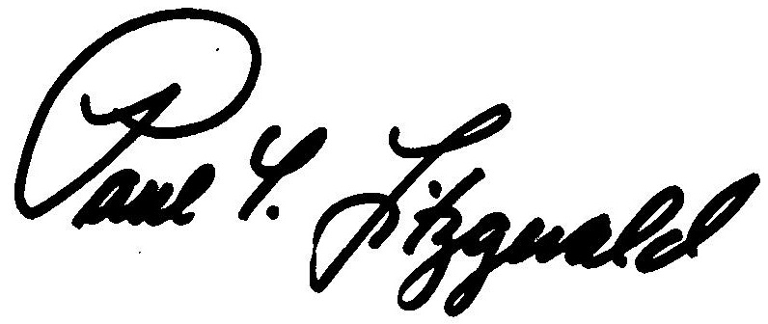
BOSTON, MASSACHUSETTS Paul T. Fitzgerald, Esq.
DATE OF DECISION – August 24, 2015 Chairman

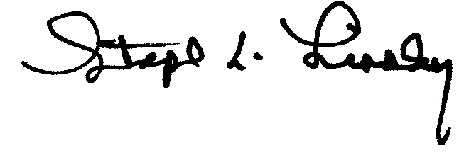
Stephen M. Linsky, Esq.
Member

Member Judith M. Neumann, Esq. did not participate in this decision.

ANY FURTHER APPEAL WOULD BE TO A MASSACHUSETTS STATE DISTRICT COURT OR THE BOSTON MUNICIPAL COURT
(See Section 42, Chapter 151A, General Laws Enclosed)

The last day to appeal this decision to a Massachusetts District Court is thirty days from the mail date on the first page of this decision. If that thirtieth day falls on a Saturday, Sunday, or legal holiday, the last day to appeal this decision is the business day next following the thirtieth day.

To locate the nearest Massachusetts District Court, see:
www.mass.gov/courts/court-info/courthouses

Please be advised that fees for services rendered by an attorney or agent to a claimant in connection with an appeal to the Board of Review are not payable unless submitted to the Board of Review for approval, under G.L. c. 151A, § 37.

SVL/rh

Board of Review Decision BR-113873 is an unpublished decision, available upon request. For privacy reasons, identifying information is redacted.

