After the claimant’s assignment with the employer’s client ended due to failure to notify the client of her absence, the employer wanted to reassign the claimant but had no other work available. Such a separation from the employer is not disqualifying under G.L. c. 151A, § 25(e)(2).

Board of Review Paul T. Fitzgerald, Esq.
19 Staniford St., 4th Floor Chairman
Boston, MA 02114 Stephen M. Linsky, Esq.
Phone: 617-626-6400 Member
Fax: 617-727-5874 Judith M. Neumann, Esq.
Member
Issue ID: 0014 4271 40
BOARD OF REVIEW DECISION

Introduction and Procedural History of this Appeal

The claimant appeals a decision by Margaret Blakely, a review examiner of the Department of Unemployment Assistance (DUA), to deny unemployment benefits. We review, pursuant to our authority under G.L. c. 151A, § 41, and reverse.

The claimant separated from her position with the employer on July 30, 2014. She filed a claim for unemployment benefits with the DUA, which was approved in a determination issued on October 9, 2014. The employer appealed the determination to the DUA hearings department. Following a hearing on the merits, attended by both parties, the review examiner overturned the agency’s initial determination and denied benefits in a decision rendered on November 19, 2014. We accepted the claimant’s application for review.

Benefits were denied after the review examiner determined that the claimant engaged in deliberate misconduct in wilful disregard of the employer’s interest and, thus, was disqualified, under G.L. c. 151A, § 25(e)(2). After considering the recorded testimony and evidence from the hearing, the review examiner’s decision, and the claimant’s appeal, we afforded the parties an opportunity to submit written reasons for agreeing or disagreeing with the decision. Neither party responded. Our decision is based upon our review of the entire record.

The issue on appeal is whether the review examiner’s conclusion that the claimant was discharged for engaging in deliberate misconduct in wilful disregard of the employer’s interest, under G.L. c. 151A, § 25(e)(2), after she failed to report an absence to the employer, is supported by substantial and credible evidence and is free from error of law.

Findings of Fact

The review examiner’s findings of fact and credibility assessments are set forth below in their entirety:

- The claimant worked as a full-time employee for the employer, a temporary agency. The claimant was assigned to work as an assembler for one of the employer’s clients, a plastic manufacturer, [until] 07/30/2014, when she separated.

- The claimant was aware of the employer’s attendance policy requiring employees to notify the temporary agency if they will be absent for their scheduled shift, as she signed it upon hire. The purpose of this policy was to ensure adequate staffing. Unexcused absences may result in termination of employment.

- The claimant was absent from work on prior unknown dates, and was not terminated.

- The employer expected the claimant to notify them if she would be absent from a scheduled shift. The purpose of this expectation was to ensure adequate staffing. The claimant was aware of this expectation having signed the attendance policy upon hire.

- The claimant’s final day at work was 07/29/2014.

- The claimant was scheduled to work, but did not work, on 07/30/2014.

- The employer has no records that the client was slow that day.

- The client reported to the temporary agency that the claimant was absent on 07/30/2014.

- The claimant did not inform the temporary agency that she would be absent from work on 07/30/2014.

- The claimant’s assignment was terminated on 07/30/2014 due to her absence and failure to notify the temporary agency of her absence.

Ruling of the Board

In accordance with our statutory obligation, we review the examiner’s decision to determine: (1) whether the findings of fact are supported by substantial and credible evidence; and (2) whether the ultimate conclusion that the claimant is not entitled to benefits is free from error of law. Upon such review and as discussed more fully below, the Board adopts the review examiner’s findings of fact. In adopting these findings, we deem them to be supported by substantial and credible evidence. However, we conclude that the findings of fact and the totality of the evidence in the record support an award of benefits to the claimant.

Since the parties agree that the claimant was discharged from her employment, her qualification for benefits is governed by G.L. c. 151A, § 25(e)(2), which provides, in pertinent part, as follows:

No waiting period shall be allowed and no benefits shall be paid to an individual under this chapter . . . (e) For the period of unemployment next ensuing . . . after the individual has left work . . . (2) by discharge shown to the satisfaction of the commissioner by substantial and credible evidence to be attributable to deliberate misconduct in wilful disregard of the employing unit’s interest, or to a knowing violation of a reasonable and uniformly enforced rule or policy of the employer, provided that such violation is not shown to be as a result of the employee’s incompetence . . . .

The review examiner concluded that the employer discharged the claimant on July 30, 2014, due to deliberate misconduct in wilful disregard of the employer’s interest, because the claimant had failed to notify the employer of her absence from work at the client company on that day. We disagree that the claimant’s separation resulted from her failure to notify the temporary agency of her absence from the client company.

The review examiner found that the client company terminated the claimant’s assignment on July 30, 2014, due to the claimant’s absence from work that day. While this finding is supported by the substantial and credible evidence in the record, the review examiner’s further conclusion, that the claimant was also discharged by the employer due to her absence and failure to report her absence to the employer, is not supported by the record before us. The employer testified at the hearing that, after the claimant’s assignment with the client ended, the employer informed the claimant it wanted to reassign her to another job, but no other work was available for the claimant. Thus, the record before us does not establish that the claimant’s assignment with the employer was terminated due to disqualifying reasons under the unemployment law, but rather because the employer did not have other suitable work available for the claimant after July 30th.

We, therefore, conclude as a matter of law that the claimant is qualified for benefits because her separation from employment was not attributable to deliberate misconduct or to a knowing violation of a rule or policy of the employer, as meant under G.L. c. 151A, § 25(e)(2).

The review examiner’s decision is reversed. The claimant is entitled to receive benefits for the week ending August 2, 2014, and for subsequent weeks if otherwise eligible.

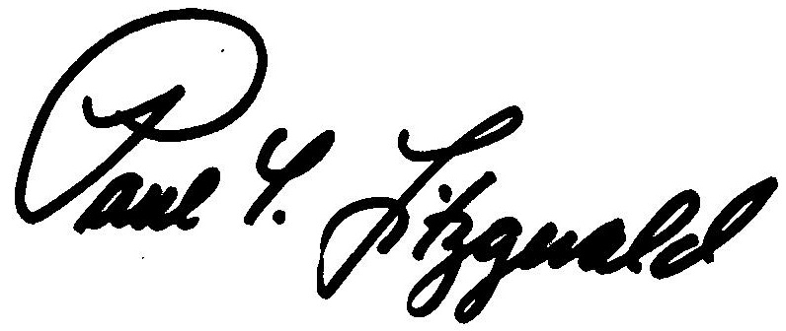
BOSTON, MASSACHUSETTS Paul T. Fitzgerald, Esq.
DATE OF DECISION - October 19, 2015 Chairman

Judith M. Neumann, Esq.
Member

Member Stephen M. Linsky, Esq. did not participate in this decision.

ANY FURTHER APPEAL WOULD BE TO A MASSACHUSETTS STATE DISTRICT COURT OR TO THE BOSTON MUNICIPAL COURT
(See Section 42, Chapter 151A, General Laws Enclosed)

The last day to appeal this decision to a Massachusetts District Court is thirty days from the mail date on the first page of this decision. If that thirtieth day falls on a Saturday, Sunday, or legal holiday, the last day to appeal this decision is the business day next following the thirtieth day.

To locate the nearest Massachusetts District Court, see:
www.mass.gov/courts/court-info/courthouses

Please be advised that fees for services rendered by an attorney or agent to a claimant in connection with an appeal to the Board of Review are not payable unless submitted to the Board of Review for approval, under G.L. c. 151A, § 37.

SVL/rh

We have supplemented the findings of fact, as necessary, with the unchallenged evidence before the review examiner. See Bleich v. Maimonides School, 447 Mass. 38, 40 (2006); Allen of Michigan, Inc. v. Deputy Dir. of Department of Employment and Training, 64 Mass. App. Ct. 370, 371 (2005).

