When a temporary employer informs a claimant that his assignment has ended, but offers no new work, the claimant is deemed to have separated due to a lack of work.

Board of Review Paul T. Fitzgerald, Esq.
19 Staniford St., 4th Floor Chairman
Boston, MA 02114 Judith M. Neumann, Esq.
Phone: 617-626-6400 Member
Fax: 617-727-5874 Charlene A. Stawicki, Esq.
Member
Issue ID: 0016 9906 45
Claimant ID: 1306005
BOARD OF REVIEW DECISION

Introduction and Procedural History of this Appeal

The claimant appeals a decision by Danielle Etienne, a review examiner of the Department of Unemployment Assistance (DUA), to deny unemployment benefits. We review, pursuant to our authority under G.L. c. 151A, § 41, and reverse.

The claimant separated from his position with the employer on September 11, 2015. He filed a claim for unemployment benefits with the DUA, which was approved in a determination issued on October 3, 2015. The employer appealed the determination to the DUA hearings department. Following a hearing on the merits, attended only by the employer, the review examiner overturned the agency’s initial determination and denied benefits in a decision rendered on December 14, 2015. We accepted the claimant’s application for review.

Benefits were denied after the review examiner determined that the claimant voluntarily left employment without good cause attributable to the employer or urgent, compelling, and necessitous reasons and, thus, was disqualified, under G.L. c. 151A, § 25(e)(1). After considering the recorded testimony and evidence from the hearing, the review examiner’s decision, and the claimant’s appeal, we remanded the case to the review examiner on January 7, 2016, to make subsidiary findings of fact from the record regarding who informed the claimant that his work assignment would be ending and whether the employer offered the claimant another assignment at that time. After the Hearings Department sent notices to the parties that a hearing would be held for the taking of additional evidence and the claimant did not appear, the review examiner returned the case to the Board. Because the review examiner had not complied with our order to make subsidiary findings of fact only, we remanded the matter again for subsidiary findings of fact on February 12, 2016. The review examiner then issued her consolidated findings of fact and returned the case to the Board on April 4, 2016. Our decision is based upon our review of the entire record.

The issue before the Board is whether the review examiner’s conclusion that the claimant voluntarily separated from her position with the employer without good cause and is subject to disqualification, under G.L. c. 151A, § 25(e)(1), is supported by substantial and credible evidence and is free from error of law, where the employer informed the claimant on September 11, 2015, that he was discharged from his assignment and the employer did not offer the claimant another assignment that day.

Findings of Fact

The review examiner’s consolidated findings of fact are set forth below in their entirety:

- The claimant worked full time for the employer from May 1, 2014 until the claimant separated on September 11, 2015.

- The claimant was assigned to work for the employer’s client until September 11, 2015.

- On September 11, 2015, the client discharged the claimant for making mistakes at work.

- The employer’s Recruiter told the claimant that the claimant was discharged from the assignment.

- At that time, the claimant did not request another assignment from the employer as the employer required.

- On September 11, 2015 the employer did not offer another assignment to the claimant.

- On September 21, 2015, the employer offered an assignment to the claimant. The assignment was to begin the following day and the claimant would work as a materials handler.

- The claimant refused the new assignment because the claimant was travelling to Senegal to visit his family.

- At that time, the claimant also informed the employer that he would not be available for work because he would be attending school.

- The claimant separated when he failed to request assignments from the employer.

- The claimant failed to request assignments from the employer for unknown reasons.

Ruling of the Board

In accordance with our statutory obligation, we review the decision made by the review examiner to determine: (1) whether the consolidated findings are supported by substantial and credible evidence; and (2) whether the review examiner’s ultimate conclusion is free from error of law. Upon such review, the Board adopts the review examiner’s consolidated findings of fact and deems them to be supported by substantial and credible evidence. However, as discussed more fully below, we reject the review examiner’s legal conclusion that the claimant is subject to disqualification, under G.L. c. 151A, § 25(e)(1). Since the employer discharged the claimant from his assignment and then did not give him more work at another assignment on September 11, 2015, we conclude that the claimant’s separation was non-disqualifying, pursuant to G.L. c. 151A, § 25(e)(2).

Resolution of the instant matter requires us to analyze two provisions of the Massachusetts unemployment statute. The first is G.L. c. 151A, § 25(e)(1), which provides, in pertinent part, as follows:

No waiting period shall be allowed and no benefits shall be paid to an individual under this chapter for . . . the period of unemployment next ensuing . . . after the individual has left work (1) voluntarily unless the employee establishes by substantial and credible evidence that he had good cause for leaving attributable to the employing unit or its agent . . . .

Also applicable to this case is another provision, under G.L. c. 151A, § 25(e), which provides, in pertinent part, as follows:

A temporary employee of a temporary help firm shall be deemed to have voluntarily quit employment if the employee does not contact the temporary help firm for reassignment before filing for benefits and the unemployment benefits may be denied for failure to do so. Failure to contact the temporary help firm shall not be deemed a voluntary quitting unless the claimant has been advised of the obligation in writing to contact the firm upon completion of an assignment.

The review examiner concluded that the claimant separated due to his failure to request another assignment after the employer told him on September 11, 2015, that he was discharged from the assignment, which began on May 1, 2014.

We have previously analyzed the above cited provisions relative to temporary employees in light of the overall purpose of the unemployment statute. This analysis has led us to conclude that the purpose of these provisions is to ensure that a temporary employer who may lack frequent contact with its employees has an opportunity to offer its employees additional work before said employees apply for unemployment benefits. See, e.g., Board of Review Decision 0002 2757 85 (September 20, 2013) (“The record in this case establishes that, well before the claimant applied for benefits, communication occurred between the parties that afforded the employer with actual notice of the claimant’s availability, [which] effectuated the relevant statutory purpose”); BR-122974 (November 2012) (where the claimant had communicated with his employer on the day his prior assignment ended, the claimant met the statutory requirement, even though the conversation focused on the status of the claimant’s employment with the prior client).

In this case, the claimant spoke with the employer at the time his assignment ended. It was during that conversation that the claimant was told that the client had discharged him. At that time (if not sooner), the employer learned about the claimant’s general availability for additional assignments. Nevertheless, the employer did not offer the claimant another assignment on September 11, 2015. Since the employer had the opportunity to offer the claimant more work but did not do so, the purpose of the statutory requirement was satisfied and the separation was, effectively, due to a lack of work offered by the employer.

We, therefore, conclude as a matter of law that the claimant is not disqualified, under G.L. c. 151A, § 25(e).

The review examiner’s decision is reversed. The claimant is entitled to receive benefits for the period beginning September 6, 2015, and for subsequent weeks if otherwise eligible.

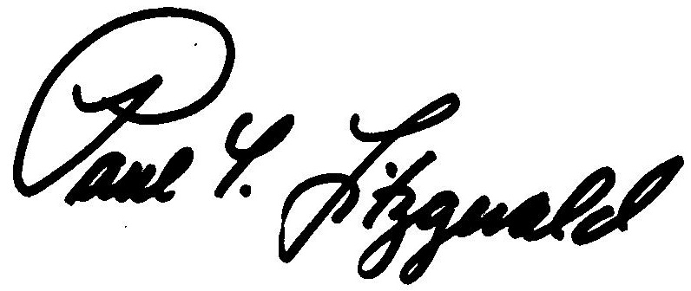
BOSTON, MASSACHUSETTS Paul T. Fitzgerald, Esq.
DATE OF DECISION - April 20, 2016 Chairman

Charlene A. Stawicki, Esq.
Member

Member Judith M. Neumann, Esq. did not participate in this decision.

ANY FURTHER APPEAL WOULD BE TO A MASSACHUSETTS STATE DISTRICT COURT OR TO THE BOSTON MUNICIPAL COURT
(See Section 42, Chapter 151A, General Laws Enclosed)

The last day to appeal this decision to a Massachusetts District Court is thirty days from the mail date on the first page of this decision. If that thirtieth day falls on a Saturday, Sunday, or legal holiday, the last day to appeal this decision is the business day next following the thirtieth day.

To locate the nearest Massachusetts District Court, see:
www.mass.gov/courts/court-info/courthouses

Please be advised that fees for services rendered by an attorney or agent to a claimant in connection with an appeal to the Board of Review are not payable unless submitted to the Board of Review for approval, under G.L. c. 151A, § 37.

SF/rh

Board of Review Decision BR-122974 is an unpublished decision, available upon request. For privacy reasons, identifying information is redacted.

