The employer’s past pattern of hiring the claimant, an adjunct professor, to teach two courses each semester and providing a specific work assignment approximately two weeks before the semester begins was not sufficient to establish reasonable assurance of re-employment. Until such an offer is made, there is no reasonable assurance under G.L. c. 151A, § 28A.

Board of Review Paul T. Fitzgerald, Esq.
19 Staniford St., 4th Floor Chairman
Boston, MA 02114 Stephen M. Linsky, Esq.
Phone: 617-626-6400 Member
Fax: 617-727-5874 Judith M. Neumann, Esq.
Member
Issue ID: 0016 2822 60
BOARD OF REVIEW DECISION

Introduction and Procedural History of this Appeal

The claimant appeals a decision by Heidi Saraiva, a review examiner of the Department of Unemployment Assistance (DUA), to deny unemployment benefits. We review, pursuant to our authority under G.L. c. 151A, § 41, and reverse.

The claimant separated from her position with the employer on May 12, 2015 and reopened a claim for benefits. In a determination issued on June 9, 2015, the DUA denied benefits for the period May 17, 2015 through September 5, 2015. The claimant appealed the determination to the DUA hearings department. Following a hearing on the merits, attended by both parties, the review examiner affirmed the agency’s initial determination and denied benefits, but further extended the period of disqualification through September 19, 2015, in a decision rendered on July 27, 2015. We accepted the claimant’s application for review.

Benefits were denied after the review examiner determined that the claimant had reasonable assurance of re-employment for the fall, 2015 academic term and, thus, was disqualified, under G.L. c. 151A, § 28A. After considering the recorded testimony and evidence from the hearing, the review examiner’s decision, and the claimant’s appeal, we afforded the parties an opportunity to submit written reasons for agreeing or disagreeing with the decision. Neither party responded. Our decision is based upon our review of the entire record.

The issue before the Board is whether the review examiner’s conclusion that the claimant had reasonable assurance of re-employment in the next academic term is supported by substantial and credible evidence and is free from error of law, where there was no evidence before the examiner that the employer had yet offered the claimant any work for the following semester.

Findings of Fact

The review examiner’s findings of fact and credibility assessments are set forth below in their entirety:

- The claimant filed an initial claim for unemployment benefits effective December 14, [2014]. The claimant worked for 1 employer, which was the instant employer, during the base period of the claim, which extends from October 1, 2013 through September 30, [2014]. The Department of Unemployment Assistance determined the claimant was monetarily eligible to receive weekly unemployment benefits in the amount of $316.00 with the use of school wages.

- The claimant has worked part time as an adjunct faculty member for the employer, an educational institution, since September 2008.

- The claimant is a lecturer in the employer’s Art department.

- Since the fall 2012 semester, the claimant has taught 2 courses for a total of 8 credits each semester.

- The claimant’s contract ends upon the completion of the semester.

- The spring 2015 semester began January 21, 2015 and ended May 12, 2015.

- The employer notifies adjunct faculty members of their work assignments approximately 2 weeks prior to the start of the semester.

- The fall 2015 semester commences the week beginning September 20, 2015.

- Over the course of the next 2 years, the employer intends to implement a 15% rule which states that no more than 15% of 3 and 4 credit courses can be taught by part time faculty during the academic year if a department has six or more full time members.

Ruling of the Board

In accordance with our statutory obligation, we review the decision made by the review examiner to determine: (1) whether the findings are supported by substantial and credible evidence; and (2) whether the review examiner’s ultimate conclusion is free from error of law. Upon such review, the Board adopts the review examiner’s findings of fact and deems them to be supported by substantial and credible evidence. However, as discussed more fully below, we conclude, contrary to the review examiner that, based upon the evidence, the claimant did not receive reasonable assurance of re-employment for the fall, 2015 semester.

As an adjunct professor employed by an educational institution, the claimant’s eligibility for benefits is subject to G.L. c. 151A, § 28A, which states in relevant part, as follows:

Benefits based on service in employment as defined in subsections (a) and (d) of section four A shall be payable in the same amount, on the same terms and subject to the same conditions as benefits payable on the basis of other service subject to this chapter, except that:

- with respect to service performed in an instructional . . . capacity for an educational institution, benefits shall not be paid on the basis of such services for any week commencing during the period between two successive academic years or terms . . . to any individual if such individual performs such services in the first of such academic years or terms and if there is a contract or a reasonable assurance that such individual will perform services in any such capacity for any educational institution in the second of such academic years or terms . . .

The findings of fact establish that the claimant typically teaches two courses each semester for the employer and that she has done so for the last three years. Based solely on this employment history, the examiner concluded that the claimant had reasonable assurance of re-employment, within the meaning of G.L. c. 151A, § 28A, for the next semester. We disagree. Reasonable assurance requires more than past practice.

In Board of Review Decision 0013 7070 58 (April 23, 2015), we stated, “Until a cognizable, even if contingent, offer of employment is extended, we cannot conclude that the claimant had reasonable assurance of re-employment . . . .” In that case, an adjunct college faculty member had not received an appointment letter for the fall semester until after the fall semester began, and we concluded that he did not have reasonable assurance prior to receiving the letter. In the present case, the record contains no offer of re-employment, contingent or otherwise. The employer’s past practice of notifying adjunct faculty members of their work assignments two weeks before the start of the semester, without evidence that such notice actually occurred in this case, and that such notice provided details regarding the expected terms and conditions of the claimant’s employment for the fall, 2015, semester, simply cannot meet the employer’s burden of establishing that it has given the claimant the statutorily-required reasonable assurance of re-employment so as to disqualify her from benefits based upon her work for this employer. Id.

We, therefore, conclude as a matter of law that the claimant did not have reasonable assurance of re-employment for the fall, 2015, semester, within the meaning of G.L. c. 151A, § 28A.

The review examiner’s decision is reversed. The claimant is entitled to receive benefits for the period May 17, 2015, through September 19, 2015, if otherwise eligible.

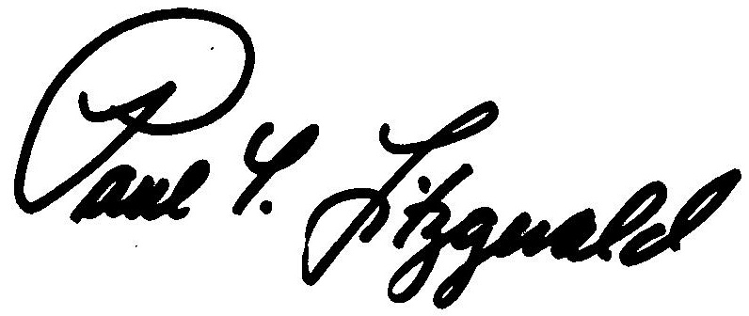
BOSTON, MASSACHUSETTS Paul T. Fitzgerald, Esq.
DATE OF DECISION - November 25, 2015 Chairman

Judith M. Neumann, Esq.
Member

Member Stephen M. Linsky, Esq. did not participate in this decision.

ANY FURTHER APPEAL WOULD BE TO A MASSACHUSETTS STATE DISTRICT COURT OR TO THE BOSTON MUNICIPAL COURT
(See Section 42, Chapter 151A, General Laws Enclosed)

The last day to appeal this decision to a Massachusetts District Court is thirty days from the mail date on the first page of this decision. If that thirtieth day falls on a Saturday, Sunday, or legal holiday, the last day to appeal this decision is the business day next following the thirtieth day.

To locate the nearest Massachusetts District Court, see:
www.mass.gov/courts/court-info/courthouses

Please be advised that fees for services rendered by an attorney or agent to a claimant in connection with an appeal to the Board of Review are not payable unless submitted to the Board of Review for approval, under G.L. c. 151A, § 37.

AB/rh

Because the review examiner did not have the correct telephone number for the claimant, the claimant did not participate personally in the hearing, but her testimony was offered and accepted through her attorney. Since the burden of production in this case lies with the employer, and its testimony was sufficient to support the findings of fact, the claimant’s absence does not affect our decision.
Board of Review Decision 0013 7070 58 is an unpublished decision, available upon request. For privacy reasons, identifying information is redacted.

