A claimant who left subsidiary part-time base period employment without foreknowledge that she would subsequently be leaving her primary job is not subject to any disqualification or constructive deduction based upon her separation from this employer.

Board of Review Paul T. Fitzgerald, Esq.
19 Staniford St., 4th Floor Chairman
Boston, MA 02114 Stephen M. Linsky, Esq.
Phone: 617-626-6400 Member
Fax: 617-727-5874 Judith M. Neumann, Esq.
Member
Issue ID: 0015 4493 28
Claimant ID: 10347872
BOARD OF REVIEW DECISION

Introduction and Procedural History of this Appeal

The claimant appeals a decision by Sandor Zapolin, a review examiner of the Department of Unemployment Assistance (DUA), to deny unemployment benefits. We review, pursuant to our authority under G.L. c. 151A, § 41, and reverse.

The claimant separated from her position with the employer on August 31, 2014. She filed a claim for unemployment benefits with the DUA, which was denied in a determination issued on February 26, 2015. Based upon its determination that the employer was a subsidiary part-time employer, the DUA imposed a constructive deduction rather than a full disqualification from benefits. The claimant appealed the determination to the DUA hearings department. Following a hearing on the merits, attended by both parties, the review examiner affirmed the agency’s initial determination that the claimant should be disqualified, but, without explanation, imposed a full disqualification rather than a constructive deduction, in a decision rendered on July 24, 2015. We accepted the claimant’s application for review.

Benefits were denied after the review examiner determined that the claimant voluntarily left employment without good cause attributable to the employer or urgent, compelling, and necessitous reasons and, thus, was disqualified, under G.L. c. 151A, § 25(e). After considering the recorded testimony and evidence from the hearing, the review examiner’s decision, and the claimant’s appeal, we afforded the parties an opportunity to submit written reasons for agreeing or disagreeing with the decision. Neither party responded. Our decision is based upon our review of the entire record.

The issue before the Board is whether the review examiner’s conclusion that the claimant should be disqualified from benefits is supported by substantial and credible evidence and is free from error of law, where the claimant separated from a subsidiary part-time employer during her base period without knowledge of any impending separation from her primary employer.

Findings of Fact

The review examiner’s findings of fact and credibility assessments are set forth below in their entirety:

- The Claimant was employed as an on-call, per diem Nursing Assistant for the Employer, a nursing home, from September 20, 2014 until August 31, 2014.

- The Claimant worked for this Employer for 24 hours per month (3 shifts) for approximately $13 per hour.

- On August 31, 2014, the Claimant became ill due to pregnancy.

- The Claimant also worked 24 hours/week at another medical facility and earned approximately $14 per hour. The Claimant is currently on a medical leave of absence from that position. The leave of absence began September 20, 2014.

- The Claimant called the Employer and stated that she was ill and would not be able to work.

- The Claimant did not request a leave of absence or any accommodation. The Claimant has previously taken a leave of absence in 2012 when she was a part-time employee of the Employer.

- The Claimant quit on August 31, 2015. The Claimant had a baby on May 18, 2015.

Ruling of the Board

In accordance with our statutory obligation, we review the decision made by the review examiner to determine: (1) whether the findings are supported by substantial and credible evidence; and (2) whether the review examiner’s ultimate conclusion is free from error of law. Upon such review, the Board adopts the review examiner’s findings of fact, except that the references in Findings # 6 to the claimant quitting on August 31, 2015, is deemed a typographical error, as the remaining findings and the record indicate that she left in 2014. In otherwise adopting the findings of fact, we deem them to be supported by substantial and credible evidence. However, as discussed more fully below, we conclude, contrary to the review examiner, that the claimant should not be disqualified from benefits based upon this separation.

The review examiner disqualified the claimant because he concluded that she had left her employment owing to pregnancy-related illness, but without having made efforts to preserve her employment by seeking a leave of absence or other means. We have no quarrel with this conclusion. However, the review examiner failed to consider the fact that the claimant’s employment by the instant employer was subsidiary part-time employment, even though the agency had made that determination and as a result had imposed only a constructive deduction, not a full disqualification from benefits. See Exhibit # 9. It is clear from the review examiner’s findings of facts, which we have adopted, that the claimant had another job, at which she worked contemporaneously with the instant job, and that the other job provided far more hours and also a higher rate of pay than did the instant job. See Findings of Fact ## 2 and 4. Under the agency’s regulations, the claimant’s other job was her primary employment and the instant job her subsidiary employment. See 430 CMR 4.73 (Definitions) and 4.74 (3) (“The claimant’s most recent work will, in the case of multiple contemporaneous employers, be presumed full-time if he or she worked more hours or earned more money in the most recent work than in all other contemporaneous employment.”)

A claimant who leaves subsidiary part time employment during her base period, prior to leaving her primary employment, is not subject to any disqualification, even a constructive deduction, unless she knew or had reason to know of an impending separation from her primary or principal work. 430 CMR 4.76(1)(a). Board of Review Decision 0011 4858 86 (June 19, 2014). In this case, the claimant left the instant subsidiary job on August 31, 2014, and only thereafter, on September 20, 2014, entered into a leave of absence (or separation) from her primary employer. Findings of Fact ## 1 and 4. Nothing in the record suggests that the claimant had any foreknowledge that she would be leaving her primary job at the time she separated from the instant employer. Accordingly, we conclude as a matter of law that she is not subject to any disqualification or constructive deduction based upon her separation from this employer.

The review examiner’s decision is reversed. The claimant is entitled to receive benefits for the week ending September 5, 2014, and for subsequent weeks if otherwise eligible.

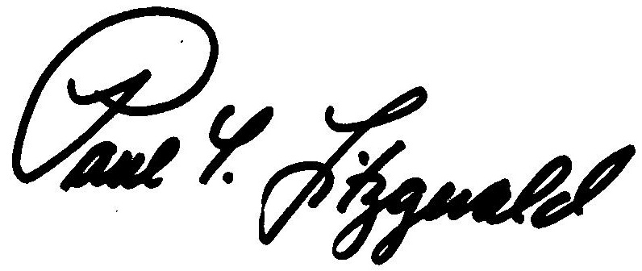
BOSTON, MASSACHUSETTS Paul T. Fitzgerald, Esq.
DATE OF DECISION - November 25, 2015 Chairman

Judith M. Neumann, Esq.
Member

Member Stephen M. Linsky, Esq. did not participate in this decision.

ANY FURTHER APPEAL WOULD BE TO A MASSACHUSETTS STATE DISTRICT COURT OR TO THE BOSTON MUNICIPAL COURT
(See Section 42, Chapter 151A, General Laws Enclosed)

The last day to appeal this decision to a Massachusetts District Court is thirty days from the mail date on the first page of this decision. If that thirtieth day falls on a Saturday, Sunday, or legal holiday, the last day to appeal this decision is the business day next following the thirtieth day.

To locate the nearest Massachusetts District Court, see:
www.mass.gov/courts/court-info/courthouses

Please be advised that fees for services rendered by an attorney or agent to a claimant in connection with an appeal to the Board of Review are not payable unless submitted to the Board of Review for approval, under G.L. c. 151A, § 37.

JN/rh

