Communicating with individuals who are Deaf or Hard of Hearing (HOH) has some distinct differences from communicating with individuals who are limited English proficient (LEP).

1) Tips to Remember when Communicating with Clients who are Deaf/HOH:
- "Sign language" is a generic term for many forms of manual communication. Not all persons who are deaf or hard of hearing (HOH) use American Sign Language (ASL) as their primary language.
- Many individuals who are Deaf/HOH are not fluent in English because it is not their “first” language. ASL has a grammatical structure that is different than English. Writing notes is not an effective means of communication, especially with complex medical, financial, or legal issues, because it requires an understanding of English, which is a "foreign" language for many individuals who are Deaf/HOH.
- Lip-reading is not a reliable means of communication. Only about 30% of a conversation is visible on the lips, and only a small percentage of the deaf are highly skilled at lip-reading.
- Many people who are Deaf or HOH do not identify as "disabled," but as members of a cultural community with its own language, values, and social norms. An individual's communication style is shaped by many factors, including educational experiences, cultural/linguistic identity of family of origin, peer influences, etc.
- Many aspects of communication (including tone, emphasis and some grammatical structures) using ASL is expressed through facial expressions.

2) Interpreter Positioning with Clients who are Deaf/HOH
In a typical interpreting situation, the Interpreter will stand next to the Non-Signing/Hearing advocate and across from the Sign Language User. The Sign Language Interpreter will sign everything said by the hearing advocate and say everything that is signed by the client who is deaf. See Diagram 1.

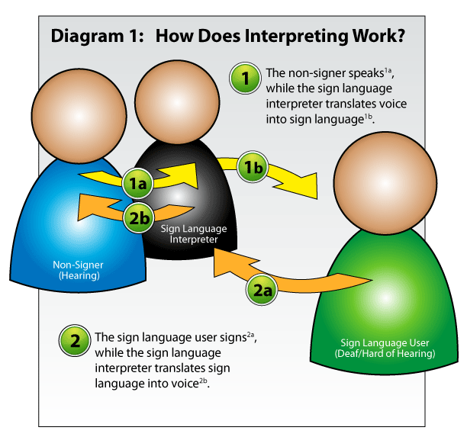
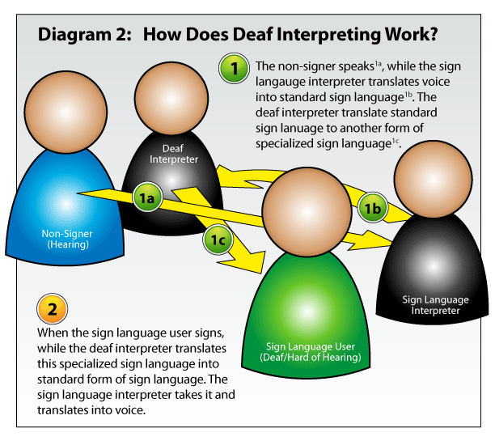

If a client does not have an adequate understanding of sign language, unable to communicate in ASL, has vision problems or developmental delays; you may need the expertise of a Deaf Interpreter. A Deaf Interpreter is often more familiar with subtle non-verbal communication styles and cultural framework that may lead to misunderstandings between the advocate and the client.

The hearing interpreter will interpret from spoken English into ASL. The Deaf Interpreter will then interpret from ASL to the appropriate level or version of sign language, which often incorporates gestures and other communication strategies. The Deaf interpreter will interpret the client's remarks into ASL. The hearing interpreter will then interpret from ASL into spoken English. The two interpreters work together to make sure that the original message does not get lost in translation. See Diagram 2.

3) Self-training for Communication Effectively with Deaf, Late Deafened and HOH Individuals:
The Massachusetts Commission for the Deaf and Hard of Hearing has a short online PowerPoint training presentation that can be found at: http://www.mass.gov/eohhs/consumer/disability-services/services-by-type/deaf-hh/communicate-train/abridged-online-training.html

(Information adapted and images used with permission from Deaf Empowerment Awareness Foundation (DEAF), Inc., www.deafinc.org and DEAF, Inc. http://www.deafinconline.org).

