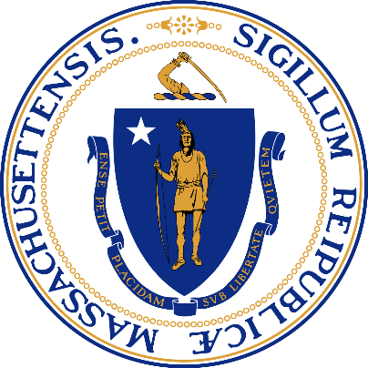
Charles D. Baker
Governor

Karyn Polito
Lieutenant Governor
Marylou Sudders
Secretary

Jeff McCue
Commissioner

Supplemental Nutrition Assistance Program Participation Rate Report

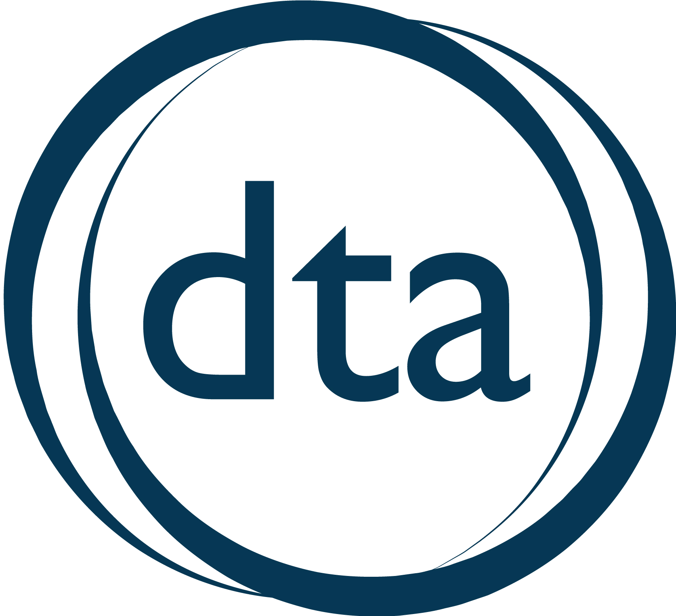
Massachusetts Department of Transitional Assistance
December 2018
DEPARTMENT OF TRANSITIONAL ASSISTANCE
SUPPLEMENTAL NUTRITION ASSISTANCE PROGRAM
PARTICIPATION RATE REPORT
DECEMBER 2018

Overview
Line-item 4400-1001 of Section 2 of Chapter 154 of the Acts of 2018 requires the Department of Transitional Assistance (DTA) to annually report the status of Supplemental Nutrition Assistance Program (SNAP) client outreach to the House and Senate Committees on Ways and Means.

Department of Transitional Assistance Mission
DTA’s mission is to assist and empower low-income individuals and families to meet their basic needs, improve their quality of life, and achieve long-term economic self-sufficiency. DTA offers a comprehensive system of programs and supports to help individuals and families achieve greater economic self-sufficiency, including food and nutritional assistance, economic assistance, and employment supports.

DTA serves one out of every eight people in the Commonwealth including working families, children, elders, and people with disabilities.

Background on SNAP in Massachusetts
SNAP is a federally-funded program that provides critical nutritional support to low-income families by helping supplement household food budgets and access nutritious food. DTA administers SNAP on behalf of the United States Department of Agriculture (USDA). One in nine residents of the Commonwealth participate in the state’s SNAP program, including families with children, elders, and persons with disabilities.

As of the beginning of November2018, DTA’s SNAP caseload was comprised of 452,703 households, consisting of 771,791 recipients. Of these recipients, 157,358 recipients were 60 or over; 269,706 were persons with disabilities; and 273,616 were age 18 or under. Of all SNAP households, 74.4% have a gross countable income of less than 100% of the federal poverty level, which equals $16,460 for a household of two.

Beyond the core responsibilities in administering the SNAP program, DTA works alongside a variety of partners contributing to the larger mission of food security in the Commonwealth.

SNAP Outreach Strategies
DTA is dedicated to ensuring SNAP benefits and related services are available to all eligible Massachusetts households. Outreach to potential new and existing SNAP clients is done through a multi-pronged approach focused on engaging targeted populations with low SNAP participation rates. The effort brings together DTA staff, inter-secretarial state agencies, community-based organizations, and contracted vendors.

Outreach Partners
Enhanced Community Based Outreach Partner System. DTA engaged with the University of Massachusetts Medical School (UMass Medical) to administer a performance-based federal reimbursement project to enhance DTA’s provider outreach activities. In federal fiscal year (FFY) 2018, DTA contracted with 63 providers, known as outreach partners. These outreach partners are responsible for client outreach and assistance with applications and recertifications. As in previous years, preliminary information shows that most Outreach Partners reached their annual application and approval goals. These providers received just over $600,000 in payments for SNAP outreach services. For FFY 2018, USDA approved an expansion of the SNAP Outreach Partner Reimbursement Project and reimbursement of up to approximately $1.2M.

Project Bread. DTA has a long-standing relationship with Project Bread. Project Bread’s Food Source Hotline performs SNAP eligibility screenings and provides application assistance for individuals interested in applying for SNAP benefits. Project Bread also assists families in need with resources to address more immediate food needs.

Community-based Trainings. DTA provides SNAP 101 trainings for community-based organizations to educate them on the SNAP program and application process. In addition, DTA provides specialized trainings to best suit the needs of organizations that work with specific populations, such as college students, elders, and persons with disabilities. In addition to existing training opportunities, DTA is coordinating with the Department of Veterans’ Services (DVS) to host five regional trainings specifically focused on SNAP services for veterans.

Targeted Outreach and Assistance for Seniors
DTA Senior Assistance Office. In January 2018, DTA introduced its Senior Assistance Office. This specialized unit was designed to meet the specific needs of the Commonwealth’s elder population. Included in this office is a dedicated phone line for elders that connects senior clients and applicants directly with a case manager. To date, the Senior Assistance Office has handled 9,221 phone calls.

The unit participated in trainings designed to provide them with additional soft skills and resources to best serve this vulnerable population. One particularly beneficial training was conducted by the Executive Office of Elder Affairs on recognizing signs of elder abuse and appropriate ways to report it. In July 2018 DTA was approved for a federal waiver that will extend the certification period for seniors and persons with a disability from two years to three years. This waiver greatly reduces the administrative burden of participating in SNAP for this population.

Collaboration with Massachusetts Council on Aging Association (MCOA). DTA and MCOA’s ongoing collaboration has resulted in 20 new Councils on Aging becoming contracted Outreach Partners effective October 2018, which provides an additional access point for seniors to DTA and compliments other efforts being employed by the agency to strengthen access to SNAP benefits for Massachusetts seniors.

Technological Enhancements
Online Client Services. In August 2016, DTA introduced a mobile application called DTA Connect that allows clients to access case information, receive alerts and reminders, and update contact information, among other things. In 2018, DTA expanded the DTA Connect platform to include a web-based portal, which affords clients maximum flexibility in accessing information and tools at any time. This expansion included a streamlined eligibility screener, an interactive, user-friendly online SNAP application and a client and provider web portal. This development significantly expands self-service capacity allowing clients to check their case and benefit status, view notices sent by DTA and upload important documents. Clients have access to DTA Connect via self-service kiosks available in all 22 local Transitional Assistance Offices. Further expansion of this platform is anticipated for 2019.

Interagency Partnerships
MassHealth. DTA and MassHealth continue to prioritize efforts to reduce what is commonly known as the “SNAP Gap”. The term refers to Massachusetts residents who receive MassHealth benefits, but are not currently receiving SNAP benefits although they’re likely eligible for them. DTA continues to use outreach partners to conduct targeted outreach to potential SNAP Gap clients. Additionally, DTA and MassHealth are in discussions on ways to capitalize on existing technology to further enhance outreach efforts.

Department of Higher Education. DTA, with assistance from the Department of Higher Education, is actively working to bring on colleges and universities as outreach partners and SNAP Employment and Training providers. In a joint effort to address the issue of food insecurity on college campuses, this approach connects higher education institutes with available federal funds to maximize services and supports to food insecure college students. In 2018, DTA was able to successfully enroll its first community college outreach partner and has expanded the number of community colleges participating in the SNAP Employment and Training program to 4, including Cape Cod Community College, Holyoke Community College, Middlesex Community College, and Quinsigamond Community College.

Department of Elementary and Secondary Education. DTA is in the early discussions with the Department of Elementary and Secondary Education around formalizing an outreach strategy targeted at engaging families with children who are not currently receiving SNAP and appear to be eligible. In 2018, DTA engaged with public school systems for the first time, bringing on two public school systems as outreach partners. This approach is designed to reach families in the community they reside and bridge any delta between children eligible for free or reduced priced meals who may be SNAP eligible. An added benefit is the increase in federal revenue that is introduced to the school systems.

Department of Developmental Services and Department of Mental Health. In 2018 DTA and the Department of Developmental Services (DDS), in partnership with the Office of Inspector General, participated in a work group focused on SNAP in Group Homes. The goal of the work group was to design streamlined operational practices and strengthen programmatic integrity between the two agencies. The work group successfully executed a Memorandum of Understanding and data sharing agreement that will ensure accurate and updated information is shared between the two agencies. In September 2018, DTA kicked off a similar work group with the Department of Mental Health (DMH) designed at achieving a similar outcome.

SNAP Path to Work Program
Since 2006, DTA has partnered with UMass Medical School to offer meaningful opportunities to SNAP clients who are not receiving economic assistance through the federal Temporary Assistance for Needy Families (TANF) program. The goal of the SNAP Path to Work program is to assist under- and unemployed SNAP participants gain valuable skills and experience, increase employability, secure employment, and establish a path towards self-sufficiency. Through a network of contracted community partners, participants receive job search assistance, job readiness training, job retention services, certain education opportunities, vocational skills training, work experience, apprenticeships, and supports.

Through this partnership, UMass Medical School is responsible for managing important components of the program, including:
- Recruiting, subcontracting, and monitoring SNAP Path to Work providers
- Assisting providers with federal reimbursement claims
- Designing and producing promotional material
- Maintaining the program’s website - snappathtowork.org

In FFY 2018, 45 contracted training providers were reimbursed about $1.5M for employment and training services provided to program participants.

To begin FFY2019, DTA has contracted with 46 SNAP Path to Work providers from across the state will provide services to program participants. USDA has approved provider reimbursements of approximately $6.6M as part of the FFY19 SNAP Employment and Training State Plan.

